

内部资料

提升政府治理能力大数据应用技术  
国家工程实验室

大数据平台技术路线  
调研分析报告（1.0版）

2017年7月26日

文档修订历史

|  |  |  |  |  |  |
| --- | --- | --- | --- | --- | --- |
| **序号** | **日期** | **修订内容** | **版本** | **修订人** | **备注** |
|  | 2017-07-26 | 创建文档，共6章，含正文4章和附件2章。  正文章节为（1）调研说明及启示、（2）平台架构及主流工具、（3）知名企业大数据平台架构、（4）行业大数据平台架构。  附件章节为（5）大数据平台主流工具/组件列表、（6）学习途径。 | 1.0 | 刘汪洋 | 第三章知名企业大数据平台架构，由于资料收集难度大，尚有部分企业待补充。 |
|  |  |  |  |  |  |
|  |  |  |  |  |  |
|  |  |  |  |  |  |
|  |  |  |  |  |  |
|  |  |  |  |  |  |
|  |  |  |  |  |  |

目 录

一、 调研说明及启示 5

二、 平台架构及主流工具 6

(一) 总体架构 6

1. 数据集成 6

2. 文件系统 8

3. 数据存储 9

4. 资源管理器 10

5. 调度器 11

6. 计算框架 11

7. 数据分析 15

8. 数据可视化 17

9. 操作框架 18

(二) 典型的大数据计算框架 18

1. 批处理框架 19

2. 流计算框架 23

3. 交互式分析框架 26

4. 其他类型框架 28

5. 大数据计算框架总结与展望 29

(三) 经典机器学习算法 30

1. 分类决策树C4.5算法 30

2. 朴素贝叶斯 30

3. 随机森林算法 31

4. 分类与回归树（CART） 32

5. 支持向量机（SVM） 32

6. K最近邻分类算法 32

7. K-means算法 32

8. Adaboost算法 32

9. Apriori算法 32

10. 最大期望（EM）算法 33

11. PageRank算法 33

三、 知名企业大数据平台架构 34

(一) Google 34

(二) Facebook 34

(三) Amazon 34

(四) Twitter 34

(五) IBM 34

(六) Cloudera 34

(七) 阿里云“数加”平台 34

(八) 百度大数据与人工智能平台 39

1. 百度天算 39

2. 百度AI开放平台 41

(九) 腾讯“数智方略” 41

(十) 华为FusionInsight平台 43

(十一) 新华三DataEngine大数据平台 44

(十二) 浪潮大数据 46

1. 云海Insight大数据平台 46

2. 天元数据 49

(十三) 中国联通公共创新大数据能力开放平台 49

(十四) 58同城 51

(十五) 启明星辰/杭州合众 52

四、 行业大数据平台架构 55

(一) 北京市政务大数据平台 55

附件1：大数据平台主流工具/组件列表 57

(一) 分布式文件系统 57

(二) 分布式编程 59

(三) NoSQL数据库 64

1. 列数据模式 64

2. 文档数据模式 65

3. 流数据模式 66

4. 键值（Key-Value）数据模式 66

5. 图数据模式 66

(四) NewSQL数据库 67

(五) SQL-on-Hadoop 68

(六) 数据采集/接入 69

(七) Service Programming 70

(八) Scheduling & DR 71

(九) 机器学习 72

(十) Benchmarking And QA Tools 73

(十一) 安全 74

(十二) 元数据管理 75

(十三) 系统部署 75

(十四) 应用 77

(十五) 开发框架 77

(十六) Categorize Pending 78

附件2：学习途径 81

(一) 开源社区 81

(二) 网络论坛 81

(三) 微信订阅号 81

(四) 书籍 81

(五) 论文 81

1. 调研说明及启示

本文档旨在调研当下大数据基础平台技术架构、计算框架、主流工具/算法等内容，为实验室科研平台选型、建设和使用提供一定的参考。

经过前期初步调研得出如下启示：大数据平台技术路线呈现出“因地制宜、开放共赢”的特点。

因地制宜：由于大数据平台架构不一定具有通用性，层次划分也没标准，因而市面上的大数据平台层出不穷。各个企业往往根据自身的业务特点选择适宜的平台架构和开发工具，例如社交网络服务公司Facebook每天会产生100亿条消息、45亿次“喜欢”按钮点击和3.5亿张新图片，将重点关注非结构化数据处理和数据关联挖掘模型等。包打天下的大数据平台一定无法落地，也不会有企业来专门开发。因此，实验室应因地制宜，重点打造可复用的、扩展能力强的共性基础框架，各个研究方向基于该框架自行选取合适的开发工具、算法模型来快速构建开发环境。

开放共赢：随着互联网技术的日新月异，越来越多的大型企业开始以服务增值或免费集成的方式向社会各界开放其存储、计算、分析等能力，以期激活全社会创新动能，共同打造一体化解决方案。诸如百度AI开放平台、腾讯“数智方略”大数据平台、阿里“数加”平台等就是当前无数开发者追逐的对象。实验室可以充分融入当前开放式开发环境，按需集成主流的工具/算法，减轻自身研发压力，将精力更多地集中在用户需求理解、解决方案策划和技术架构设计方面。

1. 平台架构及主流工具
2. 总体架构



图1 大数据平台参考架构及主流工具

1. 数据集成

数据集成框架提供了良好的机制，以协助高效地摄取和输出大数据系统之间的数据。从业务流程线到元数据框架，数据集成层皆有涵盖，从而提供全方位的数据在整个生命周期的管理和治理。

（1）数据摄入/消息传递（Ingest/Messaging）

* Flume：是Cloudera开发维护的分布式、可靠、高可用的日志收集系统。它将数据从产生、传输、处理并最终写入目标的路径的过程抽象为数据流，在具体的数据流中，数据源支持在Flume中定制数据发送方，从而支持收集各种不同协议数据。同时，Flume数据流提供对日志数据进行简单处理的能力，如过滤、格式转换等。此外，Flume还具有能够将日志写往各种数据目标（可定制）的能力。总的来说，Flume是一个可扩展、适合复杂环境的海量日志收集系统。
* Sqoop：是SQL-to-Hadoop的缩写，是Hadoop的周边工具，它的主要作用是在结构化数据存储与Hadoop之间进行数据交换。Sqoop可以将一个关系型数据库（例如MySQL、Oracle、PostgreSQL等）中的数据导入Hadoop的HDFS、Hive中，也可以将HDFS、Hive中的数据导入关系型数据库中。Sqoop充分利用了Hadoop的优点，整个数据导入导出过程都是用MapReduce实现并行化，同时，该过程中的大部分步骤自动执行，非常方便。
* Kafka：一种高吞吐量的分布式发布订阅消息系统，用Scala编写而成。它可以处理消费者规模网站中的所有动作流数据，目前已成为大数据系统在异步和分布式消息之间的最佳选择。
* Chukwa：是开源的数据收集系统，用于监控大规模分布式系统（2000+以上的节点,系统每天产生的监控数据量在T级别）。它构建在Hadoop的HDFS和MapReduce基础之上，继承了Hadoop的可伸缩性和鲁棒性。Chukwa包含一个强大和灵活的工具集，提供了数据的生成、收集、排序、去重、分析和展示等一系列功能，是Hadoop使用者、集群运营人员和管理人员的必备工具。

（2）ETL/工作流

ETL是数据抽取（Extract）、清洗（Cleaning）、转换（Transform）、装载（Load）的过程，是构建数据仓库的重要一环。

* Crunch：这是Apache旗下的一套Java API函数库，它能够大大简化编写、测试、运行MapReduce处理工作流的程序。
* Falcon：这是Apache旗下的Falcon大数据管理框架，可以帮助用户自动迁移和处理大数据集合。
* Cascading：这是一个架构在Hadoop上的API函数库，用来创建复杂的可容错的数据处理工作流。
* Oozie：是一个工作流引擎，用来协助Hadoop作业管理，Oozie字面含义是驯象之人，其寓意和Mahout一样，帮助用户更好地搞定Hadoop这头大象。

（3）元数据（Metadata）

* HCatalog：它提供了面向Apache Hadoop的数据表和存储管理服务，Apache HCatalog提供一个共享的模式和数据类型的机制，它抽象出表，使用户不必关心数据怎么存储，并提供了可操作的跨数据处理工具。

（4）序列化（Serialization）

* Protocol Buffers：由Google推广的一种与语言无关的、对结构化数据进行序列化和反序列化的机制。
* Avro：由Doug Cutting牵头开发，是一个数据序列化系统。类似于其他序列化机制，Avro可以将数据结构或者对象转换成便于存储和传输的格式，其设计目标是用于支持数据密集型应用，适合大规模数据的存储与交换。Avro提供了丰富的数据结构类型、快速可压缩的二进制数据格式、存储持久性数据的文件集、远程调用RPC和简单动态语言集成等功能。

1. 文件系统

* HDFS：是Hadoop体系中数据存储管理的基础。它是一个高度容错的系统，能检测和应对硬件故障，用于在低成本的通用硬件上运行。HDFS简化了文件的一致性模型，通过流式数据访问，提供高吞吐量应用程序数据访问功能，适合带有大型数据集的应用程序。
* Lustre：一个大规模的、安全可靠的、具备高可用性的集群文件系统，由SUN公司开发和维护的。该项目主要的目的就是开发下一代的集群文件系统，目前可以支持超过10000个节点，数以PB的数据存储量。
* GlusterFS：一个集群的文件系统，支持PB级的数据量。GlusterFS通过RDMA和TCP/IP方式将分布到不同服务器上的存储空间汇集成一个大的网络化并行文件系统。
* Alluxio：前身是Tachyon，是以内存为中心的分布式文件系统，拥有高性能和容错能力，能够为集群框架（如Spark、MapReduce）提供可靠的内存级速度的文件共享服务。
* Ceph：新一代开源分布式文件系统，主要目标是设计成基于POSIX的没有单点故障的分布式文件系统，提高数据的容错性并实现无缝的复制。
* PVFS：一个高性能、开源的并行文件系统，主要用于并行计算环境中的应用。PVFS特别为超大数量的客户端和服务器端所设计，它的模块化设计结构可轻松的添加新的硬件和算法支持。
* Quantcast File System (QFS)：是一个高性能、容错好、分布式的文件系统，用于开发支持MapReduce处理或者需要顺序读写大文件的应用。

1. 数据存储

（1）键值存储（Key Value Stores）

* Redis：是一个高性能的key-value存储系统，和Memcached类似，它支持存储的value类型相对更多，包括string（字符串）、list（链表）、set（集合）和zset（有序集合）。Redis的出现，很大程度补偿了Memcached这类key/value存储的不足，在部分场合可以对关系数据库起到很好的补充作用。
* Dynamo：这是由亚马逊工程师们设计的基于键值的高可用的分布式存储系统，具备去中心化、高可用性、高扩展性的特点。Dynamo在Amazon中得到了成功的应用，能够跨数据中心部署于上万个结点上提供服务，它的设计思想也被后续的许多分布式系统借鉴。
* Cassandra：这是由Facebook工程师设计的一个离散的分布式结构化存储系统，受亚马逊的Dynamo启发，Cassandra采用的是面向多维的键值或面向列的数据存储格式（注：Cassandra可用来管理分布在大量廉价服务器上的巨量结构化数据，并同时提供没有单点故障的高可用服务）。

（2）面向列的存储（Column Oriented Stores）

* HBase：是一个针对结构化数据的可伸缩、高可靠、高性能、分布式和面向列的动态模式数据库。和传统关系数据库不同，HBase采用了BigTable的数据模型：增强的稀疏排序映射表（Key/Value），其中，键由行关键字、列关键字和时间戳构成。HBase提供了对大规模数据的随机、实时读写访问，同时，HBase中保存的数据可以使用MapReduce来处理，它将数据存储和并行计算完美地结合在一起。
* BigTable：是一个基于Google文件系统的分布式数据存储系统，是为谷歌打拼天下的“三驾马车”之一。
* Hypertable：是一个开源、高性能、可伸缩的数据库，它采用与Google Bigtable相似的模型。它与Hadoop兼容，性能超高，其用户包括电子港湾、百度、高朋、Yelp及另外许多互联网公司。

（3）面向文档的存储（Document Oriented Stores）

* CouchDB：是一款面向文档的、开源数据存储管理系统，号称是“一款完全拥抱互联网的数据库”，它将数据存储在JSON文档中，这种文档可以通过Web浏览器来查询，并且用JavaScript来处理。它易于使用，在分布式上网络上具有高可用性和高扩展性。
* MongoDB：是一个基于分布式文件存储的数据库。由C++语言编写。旨在为web应用提供可扩展的高性能数据存储解决方案。介于关系数据库和非关系数据库之间的开源产品，是非关系数据库当中功能最丰富、最像关系数据库的产品。

（4）面向图的存储（Graph Oriented Stores）

* Neo4j：是一款目前最为流行的高性能NoSQL图数据库，它使用图来描述数据模型，把数据保存为图中的节点以及节点之间的关系。这是最流行的图数据库，用户包括Telenor、Wazoku、ebay、必能宝（Pitney Bowes）、MigRaven、思乐（Schleich）和Glowbl等。
* TitanDB：是一款Apache许可证框架下的分布式的开源图数据库，特别为存储和处理大规模图而做了大量优化。

1. 资源管理器

第一代Hadoop生态系统，其资源管理是以整体单一的调度器起家的，其代表作品为YARN。而当前的调度器则是朝着分层调度的方向演进（Mesos则是这个方向的代表作品），这种分层的调度方式，可以管理不同类型的计算工作负载，从而可获取更高的资源利用率和调度效率。

* YARN：一种新的Hadoop资源管理器，它是一个通用资源管理系统，可为上层应用提供统一的资源管理和调度，解决了旧MapReduce框架的性能瓶颈。它的基本思想是把资源管理和作业调度/监控的功能分割到单独的守护进程。在YARN平台上可以运行多个计算框架，如：MapReduce、Tez、Storm、Spark等计算框架。
* Mesos：由加州大学伯克利分校的AMPLab首先开发的一款开源群集管理软件，支持Hadoop、ElasticSearch、Spark、Storm和Kafka等架构。对数据中心而言它就像一个单一的资源池，从物理或虚拟机器中抽离了CPU，内存，存储以及其它计算资源， 很容易建立和有效运行具备容错性和弹性的分布式系统。

这些计算框架和调度器之间是松散耦合的，调度器的主要功能就是基于一定的调度策略和调度配置，完成作业调度，以达到工作负载均衡，使有限的资源有较高的利用率。

1. 调度器

（1）作业调度器

通常以插件的方式加载于计算框架之上，常见的作业调度器有4种：计算能力调度器、公平调度器、延迟调度、公平与能力调度器。

（2）资源协调器

在分布式数据系统中，协调器主要用于协调服务和进行状态管理。

* Azkaban：一款基于Java编写的任务调度系统任务调度，来自LinkedIn公司，用于管理他们的Hadoop批处理工作流。Azkaban根据工作的依赖性进行排序，提供友好的Web用户界面来维护和跟踪用户的工作流程。
* Paxos：Google的Chubby和Apache的Zookeeper，都是用Paxos作为其理论基础实现的。
* Chubby：本质上就是Paxos的实现版本，主要用于谷歌分布式锁服务。
* Zookeeper：这是Apache Hadoop框架下的Chubby开源版本。在分布式系统中如何就某个值（决议）达成一致，是一个十分重要的基础问题。ZooKeeper作为一个分布式的服务框架，解决了分布式计算中的一致性问题。在此基础上，ZooKeeper可用于处理分布式应用中经常遇到的一些数据管理问题，如统一命名服务、状态同步服务、集群管理、分布式应用配置项的管理等。ZooKeeper常作为其他Hadoop相关项目的主要组件，发挥着越来越重要的作用。

1. 计算框架

（1）运行时（Runtime）计算框架

可为不同种类的计算，提供运行时（runtime）环境。最常用的是运行时计算框架是Spark和Flink。

* Spark：是一个基于内存计算的开源集群计算系统，其特点是让数据分析更加快速。Spark是由加州大学伯克利分校的AMP实验室采用Scala语言开发而成。Spark的内存计算框架，适合各种迭代算法和交互式数据分析，能够提升大数据处理的实时性和准确性，现已逐渐获得很多企业的支持，如阿里巴巴、百度、网易、英特尔等公司均是其用户。
* Flink：Apache顶级开源项目，与HDFS完全兼容。Flink提供了基于Java和Scala的API，是一个高效、分布式的通用大数据分析引擎。更主要的是，Flink支持增量迭代计算，使得系统可以快速地处理数据密集型、迭代的任务。

（2）批处理

MapReduce是一种计算模型，用以进行大数据量的计算。Hadoop的MapReduce实现，和Common、HDFS一起，构成了Hadoop发展初期的三个组件。MapReduce将应用划分为Map和Reduce两个步骤，其中Map对数据集上的独立元素进行指定的操作，生成键-值对形式中间结果。Reduce则对中间结果中相同“键”的所有“值”进行规约，以得到最终结果。MapReduce这样的功能划分，非常适合在大量计算机组成的分布式并行环境里进行数据处理。

（3）迭代式

* Pregel：是一种面向图算法的分布式编程框架，其采用的是迭代式的计算模型。它被称之为Google后Hadoop时代的新“三驾马车”之一。另外两驾马车分别是：“交互式”大数据分析系统Dremel和网络搜索引擎Caffeine。
* Giraph：该系统建模于谷歌的Pregel，可视为Pregel的开源版本，它是一个基于Hadoop架构的、可扩展的分布式迭代图处理系统。
* GraphX：这是一个同时采用图并行计算和数据并行的计算框架，GraphX最先是加州大学伯克利分校AMPLab实验室的一个分布式图计算框架项目，后来整合到Spark中，成为其中的一个核心组件。GraphX最大的贡献在于，在Spark之上提供一站式数据解决方案，可方便高效地完成图计算的一整套流水作业。
* Hama：是一个构建Hadoop之上的基于整体同步并行计算（BSP）模型的分布式计算引擎，Hama的运行环境需要关联Zookeeper、HBase、HDFS组件。Hama中最关键的技术就是采用了BSP模型。

（4）流式

* Storm：是Twitter开源的一个类似于Hadoop的实时数据处理框架。编程模型简单，显著地降低了实时处理的难度，也是当下最具人气的流计算框架之一。与其他计算框架相比，Storm最大的优点是毫秒级低延时。
* Trident：是对Storm的更高一层的抽象，除了提供一套简单易用的流数据处理API之外，它以Batch(一组tuples)为单位进行处理，这样一来，可以使得一些处理更简单和高效。
* Samza：这是一款由Linkedin公司开发的分布式的流式数据处理框架,构建在Kafka之上，是Apache顶级开源项目。可直接利用Kafka和Hadoop YARN提供容错、进程隔离以及安全、资源管理。
* Spark Streaming：是Spark核心API的一个扩展，它并不会像Storm那样逐个处理数据流，而是在处理前，按时间间隔预先将其切分为很多小段的批处理作业。
* Yahoo S4 （Simple Scalable Streaming System）：是一个分布式流计算平台，具备通用、分布式、可扩展的、容错、可插拔等特点，程序员可以很容易地开发处理连续无边界数据流（continuous unbounded streams of data）的应用。它的目标是填补复杂专有系统和面向批处理开源产品之间的空白，并提供高性能计算平台来解决并发处理系统的复杂度。

（5）交互式

* Dremel：是多个基于Hadoop的开源SQL系统的理论基础。
* Impala：由Cloudera开发，一个开源的Massively Parallel Processing（MPP）查询引擎。与Hive相同的元数据、SQL语法、ODBC驱动程序和用户接口(Hue Beeswax)，可以直接在HDFS或HBase上提供快速、交互式SQL查询。Impala是在Dremel的启发下开发的，第一个版本发布于2012年末。Impala不再使用缓慢的Hive+MapReduce批处理，而是通过与商用并行关系数据库中类似的分布式查询引擎（由Query Planner、Query Coordinator和Query Exec Engine三部分组成），可以直接从HDFS或者HBase中用SELECT、JOIN和统计函数查询数据，从而大大降低了延迟。
* Drill：是谷歌Dremel的开源版本，Drill是一个低延迟的、能对海量数据（包括结构化、半结构化及嵌套数据）实施交互式查询的分布式数据引擎。于2012年8月份由Apache推出，让用户可以使用基于SQL的查询，查询Hadoop、NoSQL数据库和云存储服务。它能够运行在上千个节点的服务器集群上，且能在几秒内处理PB级或者万亿条的数据记录。它可用于数据挖掘和即时查询，支持一系列广泛的数据库，包括HBase、MongoDB、MapR-DB、HDFS、MapR-FS、亚马逊S3、Azure Blob Storage、谷歌云存储和Swift。
* Shark：Shark即“Hive on Spark”的含义，本质上是通过Hive的HQL解析，把HQL翻译成Spark上的RDD操作。然后通过Hive的元数据获取数据库里的表信息。HDFS上的数据和文件，最后会由Shark获取，并放到Spark上运算。Shark基于Scala语言的算子推导，可实现良好的容错机制，对执行失败的长/短任务，均能从上一个“快照点（Snapshot）”进行快速恢复。
* Dryad：是一个通用的粗颗粒度的分布式计算和资源调度引擎，其核心特性之一，就是允许用户自己构建DAG调度拓扑图。
* Stinger（Tez）：是下一代Hive，由Hortonworks主导开发，运行在YARN上的DAG计算框架。某些测试下，Stinger能提升10倍左右的性能，同时会让Hive支持更多的SQL。
* BlinkDB：可在抽样数据上实现交互式查询，其呈现出的查询结果附带有误差标识。BlinkDB 是一个用于在海量数据上运行交互式SQL查询的大规模并行查询引擎。BlinkDB允许用户通过适当降低数据精度，对数据进行先采样后计算，通过其独特的优化技术，实现了比Hive快百倍的交互式查询速度，而查询进度误差仅降低2%-10%。
* Presto：是一个开源的分布式SQL查询引擎，适用于交互式分析查询，可对250PB以上的数据进行快速地交互式分析。Presto的设计和编写是为了解决像Facebook这样规模的商业数据仓库的交互式分析和处理速度的问题。Facebook称Presto的性能比诸如Hive和MapReduce要好上10倍有多。

1. 数据分析

数据分析层中的工具，涵盖范围很广，从诸如SQL的声明式编程语言，到诸如Pig的过程化编程语言，均有涉及。另一方面，数据分析层中的库也很丰富，可支持常见的数据挖掘和机器学习算法，这些类库可拿来即用，甚是方便。

（1）分析工具

* Pig：运行在Hadoop上，是对大型数据集进行分析和评估的平台。它简化了使用Hadoop进行数据分析的要求，提供了一个高层次的、面向领域的抽象语言：Pig Latin。通过Pig Latin，数据工程师可以将复杂且相互关联的数据分析任务编码为Pig操作上的数据流脚本，通过将该脚本转换为MapReduce任务链，在Hadoop上执行。和Hive一样，Pig降低了对大型数据集进行分析和评估的门槛。
* Hive：是Hadoop中的一个重要子项目，最早由Facebook设计，是建立在Hadoop基础上的数据仓库架构，它为数据仓库的管理提供了许多功能，包括：数据ETL（抽取、转换和加载）工具、数据存储管理和大型数据集的查询和分析能力。Hive提供的是一种结构化数据的机制，定义了类似于传统关系数据库中的类SQL语言：Hive QL，通过该查询语言，数据分析人员可以很方便地运行数据分析业务。
* Kylin：是一个开源的分布式分析引擎，提供了基于Hadoop的超大型数据集（TB/PB级别）的SQL接口以及多维度的OLAP分布式联机分析。最初由eBay开发并贡献至开源社区。它能在亚秒内查询巨大的Hive表。
* SPSS：基本功能包括数据管理、统计分析、图表分析、输出管理等等。SPSS统计分析过程包括描述性统计、均值比较、一般线性模型、相关分析、回归分析、对数线性模型、聚类分析、数据简化、生存分析、时间序列分析、多重响应等几大类，每类中又分好几个统计过程，比如回归分析中又分线性回归分析、曲线估计、Logistic回归、Probit回归、加权估计、两阶段最小二乘法、非线性回归等多个统计过程，而且每个过程中又允许用户选择不同的方法及参数。SPSS也有专门的绘图系统，可以根据数据绘制各种图形。
* R：用于统计分析、绘图的语言和操作环境，是属于GNU系统的一个自由、免费、源代码开放的软件，是一个用于统计计算和统计制图的优秀工具。
* X-RIME：是一个开源的社会网络分析工具，它提供了一套基于Hadoop的大规模社会网络/复杂网络分析工具包。X-RIME在MapReduce的框架上对十几种社会网络分析算法进行了并行化与分布式化，从而实现了对互联网级大规模社会网络/复杂网络的分析。它包括HDFS存储系统上的一套适合大规模社会网络分析的数据模型、基于MapReduce实现的一系列社会网络分析分布式并行算法、X-RIME处理模型、X-RIME工具链等三部分。

（2）分析类库

* MLlib：这是在Spark计算框架中对常用的机器学习算法的实现库，该库还包括相关的测试和数据生成器。
* SparkR：这是AMPLab发布的一个R开发包，为Apache Spark提供轻量级的前端。
* Mahout：起源于2008年，最初是Apache Lucent的子项目，它在极短的时间内取得了长足的发展，现在是Apache的顶级项目。Mahout的主要目标是创建一些可扩展的机器学习领域经典算法的实现，旨在帮助开发人员更加方便快捷地创建智能应用程序。Mahout现在已经包含了聚类、分类、推荐引擎（协同过滤）和频繁集挖掘等广泛使用的数据挖掘方法。除了算法，Mahout还包含数据的输入/输出工具、与其他存储系统（如数据库、MongoDB或Cassandra）集成等数据挖掘支持架构。

（3）深度学习框架

* TensorFlow：是谷歌基于DistBelief进行研发的第二代人工智能学习系统，其命名来源于本身的运行原理。Tensor（张量）意味着N维数组，Flow（流）意味着基于数据流图的计算，TensorFlow为张量从流图的一端流动到另一端计算过程。TensorFlow是将复杂的数据结构传输至人工智能神经网中进行分析和处理过程的系统。TensorFlow可被用于语音识别或图像识别等多项机器深度学习领域，支持CNN、RNN和LSTM算法，这都是目前在Image，Speech和NLP最流行的深度神经网络模型。
* Caffe：全称是Convolutional Architecture for Fast Feature Embedding，它是一个清晰、高效的深度学习框架，是纯粹的C++/CUDA架构，支持命令行、Python和MATLAB接口，可以在CPU和GPU直接无缝切换。Caffe可以应用在视觉、语音识别、机器人、神经科学和天文学。

（4）商业智能（BI）

* Pentaho：是世界上最流行的开源商务智能软件，以工作流为核心的、强调面向解决方案而非工具组件的、基于java平台的商业智能套件。包括一个web server平台和几个工具软件：报表、分析、图表、数据集成、数据挖掘等，可以说包括了商务智能的方方面面。
* Jaspersoft：提供了灵活、可嵌入的商业智能工具，用户包括众多企业组织：高朋、冠群科技、美国农业部、爱立信、时代华纳有线电视、奥林匹克钢铁、内斯拉斯加大学和通用动力公司。
* SpagoBI：被市场分析师们称为“开源领袖”，它提供商业智能、中间件和质量保证软件，另外还提供相应的Java EE应用程序开发框架。

1. 数据可视化

* Tableau：是新一代BI软件，是桌面系统中最简单的商业智能工具软件，致力于帮助人们看清并理解数据，帮助不同个体快速且简便的分析、可视化和分享信息。
* Gephi:是一款开源免费跨平台基于JVM的复杂网络分析软件,其主要用于各种网络和复杂系统，动态和分层图的交互可视化与探测开源工具。Gephi可用于探索性数据分析、链接分析、社交网络分析、生物网络分析等。
* D3.js：提供了各种简单易用的函数，大大简化了JavaScript操作数据的难度。由于它本质上是JavaScript，所以用JavaScript也是可以实现所有功能的，但它能大大减小你的工作量，尤其是在数据可视化方面，D3已经将生成可视化的复杂步骤精简到了几个简单的函数，你只需要输入几个简单的数据，就能够转换为各种绚丽的图形。

1. 操作框架

（1）监测管理框架

* OpenTSDB：这是构建于HBase之上的实时性能评测系统。
* Ambari：提供了基于Web的直观界面，可用于配置、管理和监控Hadoop集群。目前已支持大多数Hadoop组件，包括HDFS、MapReduce、Hive、Pig、HBase、Zookeeper、Sqoop和Hcatalog等。

（2）基准测试

* YCSB：YCSB是雅虎云服务基准测试（Yahoo! Cloud Serving Benchmark）的简写。它是由雅虎出品的一款通用云服务性能测试工具。
* GridMix：该系统通过运行大量合成的作业，对Hadoop系统进行基准测试，从而获得性能评价指标。

（3）集群管理

（4）开发管理

（5）用户管理

（6）运维管理

（7）安全管理

1. 典型的大数据计算框架

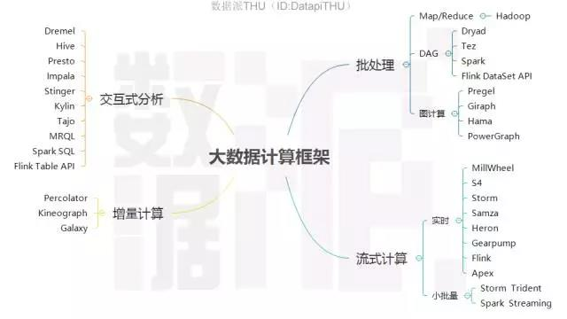

图2 大数据计算框架全景图

1. 批处理框架
2. Hadoop

Hadoop最初主要包含分布式文件系统HDFS和计算框架MapReduce两部分，是从Nutch中独立出来的项目。在2.0版本中，又把资源管理和任务调度功能从MapReduce中剥离形成YARN，使其他框架也可以像MapReduce那样运行在Hadoop之上。与之前的分布式计算框架相比，Hadoop隐藏了很多繁琐的细节，如容错、负载均衡等，更便于使用。

Hadoop也具有很强的横向扩展能力，可以很容易地把计算机接入到集群中参与计算。在开源社区的支持下，Hadoop不断发展完善，并集成了众多优秀的产品如非关系数据库HBase、数据仓库Hive、数据处理工具Sqoop、机器学习算法库Mahout、一致性服务软件Zookeeper、管理工具Ambari等，形成了相对完整的生态圈和分布式计算事实上的标准。



图3 Hadoop生态圈（删减版）

MapReduce可以理解为把一堆杂乱无章的数据按照某种特征归并起来，然后处理并得到最后的结果。基础处理步骤如下：

1）把输入文件按照一定的标准分片，每个分片对应一个map任务，一般情况下，MapReduce和HDFS运行在同一组计算机上，也就是说，每台计算机同时承担存储和计算任务，因此分片通常不涉及计算机之间的数据复制。

2）按照一定的规则把分片中的内容解析成键值对。通常选择一种预定义的规则即可。

3）执行map任务，处理每个键值对，输出零个或多个键值对。

4）MapReduce获取应用程序定义的分组方式，并按分组对map任务输出的键值对排序。默认每个键名一组。

5）待所有节点都执行完上述步骤后，MapReduce启动Reduce任务。每个分组对应一个Reduce任务。

6）执行Reduce任务的进程通过网络获取指定组的所有键值对。

7）把键名相同的值合并为列表。

8）执行Reduce任务，处理每个键对应的列表，输出结果。



图4 MapReduce处理过程

在上面的步骤中，应用程序主要负责设计map和reduce任务，其他工作均由框架负责。在定义map任务输出数据的方式时，键的选择至关重要，除了影响结果的正确性外，也决定数据如何分组、排序、传输，以及执行reduce任务的计算机如何分工。

1. DAG（有向无环图）模型

多个MapReduce通过组合可以表达复杂的计算问题，但是组合过程需要人工设计，比较麻烦。另外，每个阶段都需要所有的计算机同步，影响了执行效率。

为了克服上述问题，业界提出了DAG（有向无环图）计算模型，其核心思想是把任务在内部分解为若干存在先后顺序的子任务，由此可更灵活地表达各种复杂的依赖关系。Microsoft Dryad、Google FlumeJava、Apache Tez是最早出现的DAG模型。Dryad定义了串接、全连接、融合等若干简单的DAG模型，通过组合这些简单结构来描述复杂的任务，FlumeJava、Tez则通过组合若干MapReduce形成DAG任务。



图5 MapReduce（左）与Tez（右）执行复杂任务时对比

MapReduce的另一个不足之处是使用磁盘存储中间结果，严重影响了系统的性能，这在机器学习等需要迭代计算的场合更为明显。加州大学伯克利分校AMP实验室开发的Spark克服了上述问题。Spark对早期的DAG模型作了改进，提出了基于内存的分布式存储抽象模型RDD（Resilient Distributed Datasets，弹性分布式数据集），把中间数据有选择地加载并驻留到内存中，减少磁盘IO开销。与Hadoop相比，Spark基于内存的运算要快100倍以上，基于磁盘的运算也要快10倍以上。



图6 MapReduce与Spark中间结果保存方式对比

Spark为RDD提供了丰富的操作方法，其中map、filter、flatMap、sample、groupByKey、reduceByKey、union、join、cogroup、mapValues、sort、partionBy用于执行数据转换，生成新的RDD，而count、collect、reduce、lookup、save用于收集或输出计算结果。整个程序开发代码量不大，并且支持Java、Scala、Python、R等多种开发语言，比MapReduce编程要方便得多。



图7 RDD reduceByKey内部实现

RDD由于把数据存放在内存中而不是磁盘上，因此需要比Hadoop更多地考虑容错问题。分布式数据集的容错有两种方式：数据检查点和记录数据的更新。处理海量数据时，数据检查点操作成本很高，因此Spark默认选择记录更新的方式。不过如果更新粒度太细太多，记录更新成本也不低。因此，RDD只支持粗粒度转换，即只记录单个块（Block）上执行的单个操作，然后将创建RDD的一系列变换序列记录下来，类似于数据库中的日志。

当RDD的部分分区数据丢失时，Spark根据之前记录的演变过程重新运算，恢复丢失的数据分区。Spark生态圈的另一项目Alluxio（原名Tachyon）也采用类似的思路，使数据写入速度与HDFS有数量级的提升。

下面总结Spark对MapReduce的改进：

* MapReduce抽象层次低，需要手工编写代码完成；Spark基于RDD抽象，使数据处理逻辑的代码非常简短。
* MapReduce只提供了map和reduce两个操作，表达力欠缺；Spark提供了很多转换和动作，很多关系数据库中常见的操作如JOIN、GROUP BY已经在RDD中实现。
* MapReduce中，只有map和reduce两个阶段，复杂的计算需要大量的组合，并且由开发者自己定义组合方式；Spark中，RDD可以连续执行多个转换操作，如果这些操作对应的RDD分区不变的话，还可以放在同一个任务中执行。
* MapReduce处理逻辑隐藏在代码中，不直观；Spark代码不包含操作细节，逻辑更清晰。
* MapReduce中间结果放在HDFS中；Spark中间结果放在内存中，内存放不下时才写入本地磁盘而不是HDFS，这显著提高了性能，特别是在迭代式数据处理的场合。
* MapReduce中，reduce任务需要等待所有map任务完成后才可以开始，在Spark中，分区相同的转换构成流水线放到同一个任务中运行。

1. 流计算框架
2. 流计算概述

在大数据时代，数据通常都是持续不断动态产生的。在很多场合，数据需要在非常短的时间内得到处理，并且还要考虑容错、拥塞控制等问题，避免数据遗漏或重复计算。流计算框架则是针对这一类问题的解决方案。流计算框架一般采用DAG（有向无环图）模型，图中的节点分为两类：一类是数据的输入节点，负责与外界交互而向系统提供数据；另一类是数据的计算节点，负责完成某种处理功能如过滤、累加、合并等。从外部系统不断传入的实时数据则流经这些节点，把它们串接起来。如果把数据流比作水的话，输入节点好比是喷头，源源不断地出水，计算节点则相当于水管的转接口。

为提高并发性，每一个计算节点对应的数据处理功能被分配到多个任务（相同或不同计算机上的线程）。在设计DAG时，需要考虑如何把待处理的数据分发到下游计算节点对应的各个任务，这在实时计算中称为分组（Grouping）。最简单的方案是为每个任务复制一份，不过这样效率很低，更好的方式是每个任务处理数据的不同部分。随机分组能达到负载均衡的效果，应优先考虑。不过在执行累加、数据关联等操作时，需要保证同一属性的数据被固定分发到对应的任务，这时应采用定向分组。在某些情况下，还需要自定义分组方案。



图8 流计算分组

由于应用场合的广泛性，目前市面上已经有不少流计算平台，包括Google MillWheel、Twitter Heron和Apache Storm、Samza、S4、Flink、Apex、Gearpump。

1. Storm及Trident

在流计算框架汇总，目前人气最高、应用最广泛的要数Storm。这是由于Storm具有简单的编程模型，且支持Java、Ruby、Python等多种开发语言。Storm也具有良好的性能，在多节点集群上每秒可以处理上百万条消息。Storm在容错方面也设计得很优雅。下面介绍Storm确保消息可靠性的思路。

在DAG模型中，确保消息可靠的难点在于，原始数据被当前的计算节点成功处理后，还不能被丢弃，因为它生成的数据仍然可能在后续的计算节点上处理失败，需要由该消息重新生成。而如果要对消息在各个计算节点的处理情况都作跟踪记录的话，则会消耗大量资源。

Storm的解决思路，是为每条消息分派一个ID作为唯一性标识，并在消息中包含原始输入消息的ID。同时用一个响应中心（Acker）维护每条原始输入消息的状态，状态的初值为该原始输入消息的ID。每个计算节点成功执行后，则把输入和输出消息的ID进行异或，再异或对应的原始输入消息的状态。由于每条消息在生成和处理时分别被异或一次，则成功执行后所有消息均被异或两次，对应的原始输入消息的状态为0。因此当状态为0后可安全清除原始输入消息的内容，而如果超过指定时间间隔后状态仍不为0，则认为处理该消息的某个环节出了问题，需要重新执行。



图9 Storm保证消息可靠过程示意图

Storm还实现了更高层次的抽象框架Trident。Trident以微批处理的方式处理数据流，比如每次处理100条记录。Trident提供了过滤、分组、连接、窗口操作、聚合、状态管理等操作，支持跨批次进行聚合处理，并对执行过程进行优化，包括多个操作的合并、数据传输前的本地聚合等。以微批处理方式处理数据流的框架还有Spark Streaming。

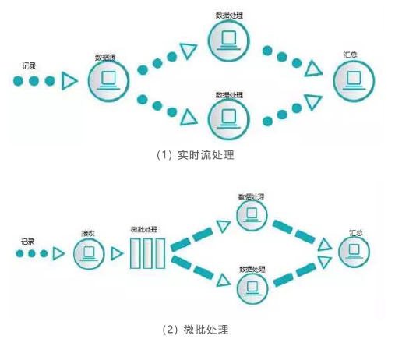

图10 实时流处理与微批处理比较

下面是Storm、Trident与另外几种流计算框架的对比：

|  |  |  |  |  |  |
| --- | --- | --- | --- | --- | --- |
|  | **Storm** | **Trident** | **Spark Streaming** | **Samza** | **Flink** |
| **模型** | 实时流 | 微批处理 | 微批处理 | 实时流 | 实时流 |
| **API** | 组合式 | 组合式 | 声明式 | 组合式 | 声明式 |
| **可靠性保证** | 至少一次 | 正好一次 | 正好一次 | 至少一次 | 正好一次 |
| **容错方式** | 记录确认 | 记录确认 | 记录更新 | 日志 | 检查点 |
| **状态管理** | 无 | 有 | 有 | 有 | 有 |
| **延迟** | 很低 | 中 | 中 | 低 | 低 |
| **吞吐量** | 低 | 中 | 高 | 高 | 高 |
| **成熟度** | 高 | 高 | 高 | 中 | 低 |

1. 交互式分析框架
2. 概述

在解决了大数据的可靠存储和高效计算后，如何为数据分析人员提供便利日益受到关注，而最便利的分析方式莫过于交互式查询。这几年交互式分析技术发展迅速，目前这一领域知名的平台有十余个，包括Google开发的Dremel和PowerDrill、Facebook开发的Presto、Hadoop服务商Cloudera和HortonWorks分别开发的Impala和Stinger，以及Apache项目Hive、Drill、Tajo、Kylin、MRQL等。

一些批处理和流计算平台如Spark和Flink也分别内置了交互式分析框架。由于SQL已被业界广泛接受，目前的交互式分析框架都支持用类似SQL的语言进行查询。早期的交互式分析平台建立在Hadoop的基础上，被称作SQL-on-Hadoop。后来的分析平台改用Spark、Storm等引擎。

1. Hive

Apache Hive是最早出现的架构于Hadoop基础之上的大规模数据仓库，由Facebook设计并开源。Hive的基本思想是，通过定义模式信息，把HDFS中的文件组织成类似传统数据库的存储系统。Hive保持着Hadoop所提供的可扩展性和灵活性。Hive支持熟悉的关系数据库概念，例如表、列和分区，包含对非结构化数据一定程度的SQL支持。它支持所有主要的原语类型（如整数、浮点数、字符串）和复杂类型（如字典、列表、结构）。它还支持使用类似SQL的声明性语言Hive Query Language（HiveQL）表达的查询。HiveQL被编译为MapReduce过程执行。下面说明如何通过MapReduce实现JOIN和GROUP BY。

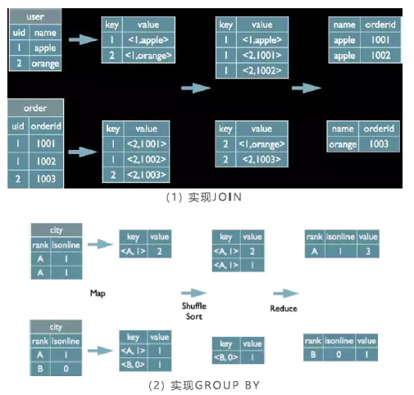

图11 部分HiveQL操作的实现方式

Hive与传统关系数据库对比如下：

|  |  |  |
| --- | --- | --- |
|  | **Hive** | **关系数据库** |
| **事务** | 不支持 | 支持 |
| **随机插入数据** | 不支持 | 支持 |
| **执行延迟** | 高 | 低 |
| **执行** | MapReduce | 数据库引擎 |
| **横向扩展** | 支持上百个节点 | 很少超过20个节点 |
| **数据规模** | 大 | 小 |
| **硬件要求** | 普通机器 | 高端专用机器 |
| **字节成本** | 低 | 高 |

Hive的主要弱点是由于建立在MapReduce的基础上，性能受到限制。很多交互式分析平台基于对Hive的改进和扩展，包括Stinger、Presto、Kylin等。其中Kylin是中国团队提交到Apache上的项目，其与众不同的地方是提供多维分析（OLAP）能力。Kylin对多维分析可能用到的度量进行与计算，供查询时直接访问，由此提供快速查询和高并发能力。Kylin在eBay、百度、京东、网易、美团均有应用。

1. SQL引擎Calcite

对于交互式分析，SQL查询引擎的优劣对性能的影响举足轻重。Spark开发了自己的查询引擎Catalyst，而包括Hive、Drill、Kylin、Flink在内的很多交互式分析平台及数据仓库使用Calcite（原名optiq）作为SQL引擎。Calcite是一个Apache孵化项目，其创建者Julian Hyde曾是Oracle数据库SQL引擎的主要开发者。Calcite具有以下几个技术特点：

* 支持标准SQL语言。
* 支持OLAP。
* 支持对流数据的查询。
* 独立于编程语言和数据源，可以支持不同的前端和后端。
* 支持关系代数、可定制的逻辑规划规则和基于成本模型优化的查询引擎。
* 支持物化视图（materialized view）的管理。

由于分布式场景远比传统的数据存储环境更复杂，Calcite和Catalyst都还处于向Oracle、MySQL等经典关系数据库引擎学习的阶段，在性能方面还有很大的提升空间。

1. 其他类型框架
2. 图计算模型

图计算是DAG之外的另一种迭代式计算模型，它以图论为基础对现实世界建模和计算，擅长表达数据之间的关联性，适用于PageRank计算、社交网络分析、推荐系统及机器学习。这一类框架有Google Pregel、Apache Giraph、Apache Hama、PowerGraph，其中PowerGraph是这一领域目前最杰出的代表。很多图数据库也内置图计算框架。

1. 增量计算框架

只对部分新增数据进行计算来提升计算过程的效率，可应用到数据增量或周期性更新的场合。这一类框架包括Google Percolator、Microsoft Kineograph、阿里Galaxy等。

1. 高性能事务处理框架

Apache Ignite、Apache Geode（GemFire的开源版本）。

1. 大数据计算框架总结与展望

从Hadoop横空出世到现在10余年的时间中，大数据分布式计算技术得到了迅猛发展。不过由于历史尚短，这方面的技术远未成熟。各种框架都在不断改进，并相互竞争。

性能优化毫无疑问是大数据计算框架改进的重点方向之一。而性能的提高很大程度上取决于内存的有效利用，例如内存计算，现已在各种类型的框架中广泛应用。内存资源的分配管理对性能也有重要影响，JVM垃圾回收在给开发人员带来便利的同时，也制约了内存的有效利用。另外，Java的对象创新及序列化也比较浪费资源。在内存优化方面做得比较好的是Flink。出于性能方面的考虑，Flink很多组件自行管理内存，无需依赖JVM垃圾回收机制。Flink还用到开辟内存池、用二进制数据代替对象、量身定制序列化、定制缓存友好的算法等优化手段。Flink还在任务的执行方面进行优化，包括多阶段并行执行和增量迭代。

拥抱机器学习和人工智能也是大数据计算的潮流之一。Spark和Flink分别推出机器学习库Spark ML和Flink ML。更多的平台在第三方大数据计算框架上提供机器学习，如Mahout、Oryx及一系列Apache孵化项目SystemML、HiveMall、PredictionIO、SAMOA、MADLib。这些机器学习平台一般都同时支持多个计算框架，如Mahout同时以Spark、Flink、H2O为引擎，SAMOA则使用S4、Storm、Samza。在深度学习掀起热潮后，又有社区探索把深度学习框架与现有分布式计算框架结合起来，这样的项目有SparkNet、Caffe on Spark、TensorFrames等。

在同一平台上支持多种框架也是发展趋势之一，尤其对于开发实力较为雄厚的社区。Spark以批处理模型为核心，实现了交互式分析框架Spark SQL、流计算框架Spark Streaming（及正在实现的Structured Streaming）、图计算框架GraphX、机器学习库Spark ML。而Flink除了提供低延迟的流计算以外，还提供批处理、关系计算、图计算、机器学习等多个框架。Google的BEAM（意为Batch+strEAM）则试图把Spark、Flink、Apex这样的计算框架纳入自己制定的标准之下。



图12 Google BEAM的统一模型

1. 经典机器学习算法
2. 分类决策树C4.5算法

C4.5是机器学习算法中的一种分类决策树算法，它是决策树的核心算法，是ID3的改进算法。决策树构造方法其实就是每次选择一个好的特征以及分裂点作为当前节点的分类条件。

C4.5相比于ID3改进的地方有：

（1）用信息增益率来选择属性。

ID3选择属性用的是子树的信息增益，这里可以用很多方法来定义信息，ID3使用的是熵(entropy，熵是一种不纯度度量准则)，也就是熵的变化值。而C4.5用的是信息增益率。一般来说“率”是用来取平衡用的，如同方差的作用。因此，C4.5克服了ID3用信息增益选择属性时偏向选择取值多的属性的不足。

（2）在树构造过程中进行剪枝，在构造决策树的时候，那些挂着几个元素的节点，不考虑最好，不然容易导致overfitting。

（3）对非离散数据也能处理。

（4）能够对不完整数据进行处理。

1. 朴素贝叶斯

在众多的分类模型中，应用最为广泛的两种分类模型是决策树模型(Decision Tree Model)和朴素贝叶斯模型（Naive Bayesian Model，NBC）。

朴素贝叶斯模型发源于古典数学理论，有着坚实的数学基础，以及稳定的分类效率。同时，NBC模型所需估计的参数很少，对缺失数据不太敏感，算法也比较简单。理论上，NBC模型与其他分类方法相比具有最小的误差率。但是实际上并非总是如此，这是因为NBC模型假设属性之间相互独立，这个假设在实际应用中往往是不成立的，这给NBC模型的正确分类带来了一定影响。在属性个数比较多或者属性之间相关性较大时，NBC模型的分类效率比不上决策树模型。而在属性相关性较小时，NBC模型的性能最为良好。

1. 随机森林算法

在源数据中随机选取数据，组成几个子集。S矩阵是源数据，有N条数据，A、B、C是feature，最后一列C是类别。

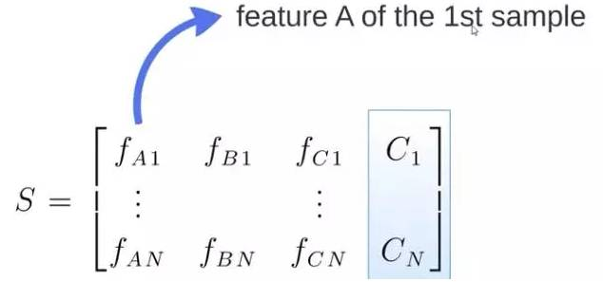

由S随机生成M个子矩阵，这M个子集得到M个决策树。将新数据投入到这M个树中，得到M个分类结果，计数看预测成哪一类的数目最多，就将此类别作为最后的预测结果。

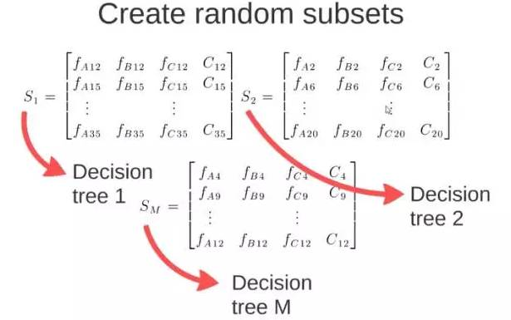

1. 分类与回归树（CART）

分类与回归树（Classification and Regression Trees，CART）有两个关键的思想：第一个是关于递归地划分自变量空间的想法；第二个想法是用验证数据进行剪枝。

1. 支持向量机（SVM）

支持向量机（Support Vector Machine）是一种监督式学习的方法，它广泛地应用于统计分类以及回归分析中。

支持向量机将向量映射到一个更高维的空间里，在这个空间里建立有一个最大间隔超平面。在分开数据的超平面的两边建有两个互相平行的超平面，分隔超平面使两个平行超平面的距离最大化。假定平行超平面间的距离或差距越大，分类器的总误差越小。

1. K最近邻分类算法

K最近邻(K-Nearest Neighbor，KNN)分类算法，是一个理论上比较成熟的方法，也是最简单的机器学习算法之一。该方法的思路是：如果一个样本在特征空间中的k个最相似（即特征空间中最邻近）的样本中的大多数属于某一个类别，则该样本也属于这个类别。

1. K-means算法

K-means算法是一个聚类算法，把n的对象根据他们的属性分为k个分割(k<n)。它与处理混合正态分布的最大期望算法很相似，因为他们都试图找到数据中自然聚类的中心。它假设对象属性来自于空间向量，并且目标是使各个群组内部的均方误差总和最小。

1. Adaboost算法

Adaboost是一种迭代算法，其核心思想是针对同一个训练集训练不同的分类器(弱分类器)，然后把这些弱分类器集合起来，构成一个更强的最终分类器(强分类器)。其算法本身是通过改变数据分布来实现的，它根据每次训练集之中每个样本的分类是否正确，以及上次的总体分类的准确率，来确定每个样本的权值。将修改过权值的新数据集送给下层分类器进行训练，最后将每次训练得到的分类器融合起来，作为最后的决策分类器。

1. Apriori算法

Apriori算法是一种最有影响的挖掘布尔关联规则频繁项集的算法，其核心是基于两阶段频集思想的递推算法。该关联规则在分类上属于单维、单层、布尔关联规则。在这里，所有支持度大于最小支持度的项集称为频繁项集，简称频集。

1. 最大期望（EM）算法

在统计计算中，最大期望（EM，Expectation–Maximization）算法是在概率模型中寻找参数最大似然估计的算法，其中概率模型依赖于无法观测的隐藏变量。最大期望算法经常用在机器学习和计算机视觉的数据集聚领域。

1. PageRank算法

PageRank是Google算法的重要内容。2001年9月被授予美国专利，专利人是Google创始人之一拉里·佩奇（Larry Page）。

PageRank根据网站的外部链接和内部链接的数量和质量，衡量网站的价值。PageRank背后的概念是：每个到页面的链接都是对该页面的一次投票，被链接的越多，就意味着被其他网站投票越多。

这个就是所谓的“链接流行度”——衡量多少人愿意将他们的网站和你的网站挂钩。PageRank这个概念引自学术中一篇论文的被引述的频度——即被别人引述的次数越多，一般判断这篇论文的权威性就越高。

1. 知名企业大数据平台架构
2. Google

资料收集难度大，待补充。

1. Facebook

资料收集难度大，待补充。

1. Amazon

资料收集难度大，待补充。

1. Twitter

资料收集难度大，待补充。

1. IBM

2016年10月26日，IBM推出沃森数据平台（Watson Data Platform）。

资料收集难度大，待补充。

1. Cloudera

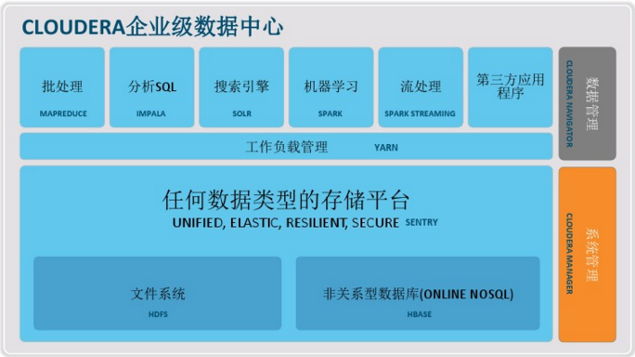

图13 Cloudera企业级数据中心

1. 阿里云“数加”平台

2016年1月20日，阿里云在2016云栖大会上海峰会上宣布开放阿里巴巴十年的大数据能力，发布全球首个一站式大数据平台“数加”。

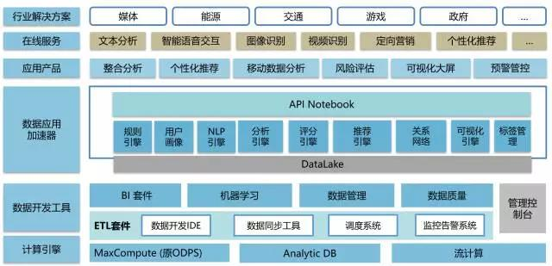

图14 阿里“数加”平台生态（截至2016年10月）

“数加”平台生态由如下三个层面来构成。

1. 数加底层技术平台

主要包括：

* 离线计算（MaxCompute，原名ODPS）是“数加”底层的计算引擎。有两个维度可以看这个计算引擎的性能，1)6小时处理100PB数据，相当于1亿部高清电影。2)单集群规模过万台，并支持多集群联合计算。
* 分析型数据库（Analytic DB）是实时多维分析引擎，可以实现百亿量级多维查询只需100毫秒。阿里巴巴内部很多面向海量互联网用户的产品的在线大数据查询，很大程度上依赖于Analytic DB。
* 流计算（StreamCompute）具有低延时、高性能的特点。每秒查询率可以达到千万级，日均处理万亿条消息、PB量级的数据。

计算引擎之上，“数加”提供了最丰富的云端数据开发套件，开发者可一站式完成数据加工。这些产品包含：数据集成、数据开发、调度系统、数据管理、运维视屏、数据质量、任务监控。

整体来看，大数据开发套件的优势包括：支持100人以上协同设计、开发、运维；具有良好的扩展性；提供各个产品功能模块的Open API，可二次开发；多个数据实例之间的数据授权机制，确保数据只能使用却不可见；提供白屏化的运维能力，以及字段级数据质量监控、机器预警、资源使用率监控等功能，让用户更好的掌控自己的数据及数据任务。

1. 数加应用平台生态体系

基于上面的技术平台，阿里在数加上还开放了规则引擎、推荐引擎、文字识别、智能语音交互、DataV可视化等数据引擎、服务、产品。这些产品很多都是从阿里自身的业务中提炼出来的，可以直接提供给企业使用，并组合成各种不同的解决方案。比如：

* “数加”发布的机器学习，可基于海量数据实现对用户行为、行业走势、天气、交通等的预测。图形化编程让用户无需编码、只需用鼠标拖拽标准化组件即可完成开发。产品还集成了阿里巴巴核心算法库，包括特征工程、大规模机器学习、深度学习等。
* 规则引擎是一款用于解决业务规则频繁变化的在线服务，可通过简单组合预定义的条件因子编写业务规则，并做出业务决策。比如，银行会设置如果10分钟内用户在两个省份交易，则需要电话确认。
* 推荐引擎是一款用于实时预测用户对物品偏好的数据工具，它能够帮助客户发现众多物品中用户最感兴趣什么。
* 文字识别提供自然场景下拍摄的图片中英文文字检测、识别以及常见的证件类检测和识别。
* 智能语音交互基于语音和自然语言技术构建的在线服务，为智能手机、智能电视以及物联网等产品提供“能听、会说、懂你”式的智能人机交互体验。

基于底层的技术平台，上层开放则可以形成丰富的生态。通过开放式的平台，凝聚行业的力量，为更多的企业和个人提供大数据服务，这就是普惠的时代。大到行业的数据分析，预测行业发展方向；小到我们每一个个体，都可以享受大数据的服务，方便个人生活。

1. 数加交易生态体系

基于技术平台与应用平台，未来可以在数加上构建一个大数据的交易市场，可以包括：

* 应用交易：算法作为大数据时代的一个重要要素，未来也是可交易的。基于算法的各种引擎，服务，应用等，既然可以基于数加来开发，就可以不仅仅是自己用，甚至作为一个公共的服务或者产品来出售。
* 数据交易：数据是大数据时代的重要基本要素之一，也是大数据时代的基础生产资料，大数据时代的血液。作为如此重要的生产资料，必须流通才能发挥大数据最大的价值。数加通过多租户，可用不可见，担保交易等设计，未来可以解决数据交易上的各种问题。当然，如果要实现大数据的交易，必须先解决数据的隐私、安全、法律法规、监管等问题。在这些问题没解决之前，仍有很长的路需要尝试。

以下是2017年6月调研情况：

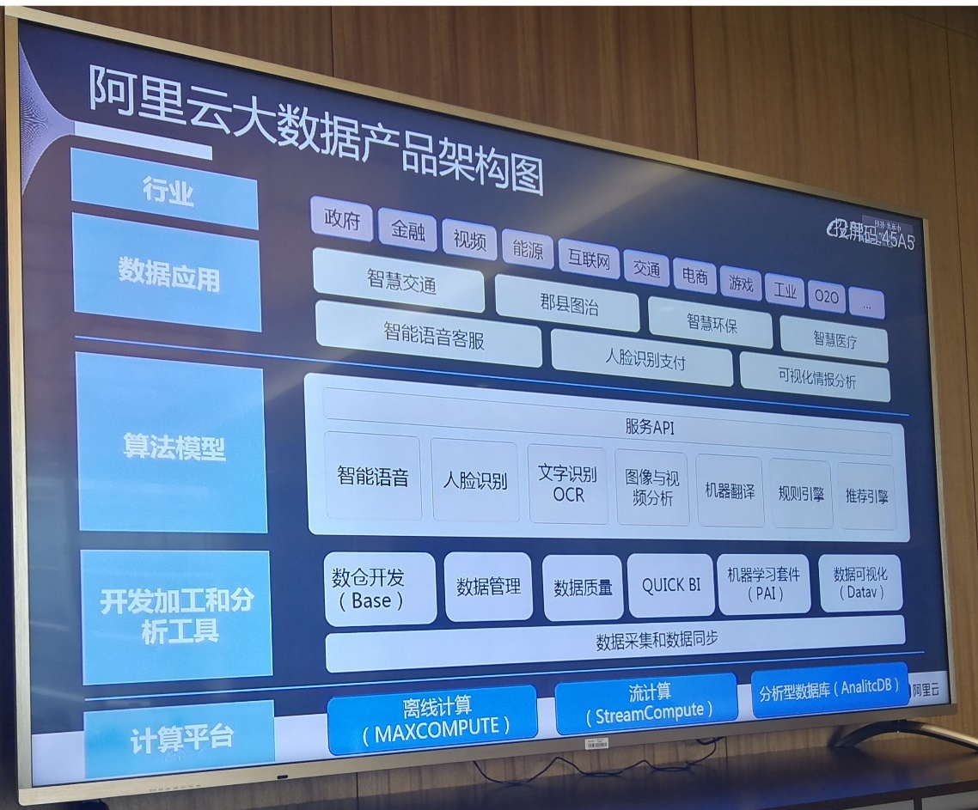

图15 阿里云大数据产品架构图（2017年6月拍摄）

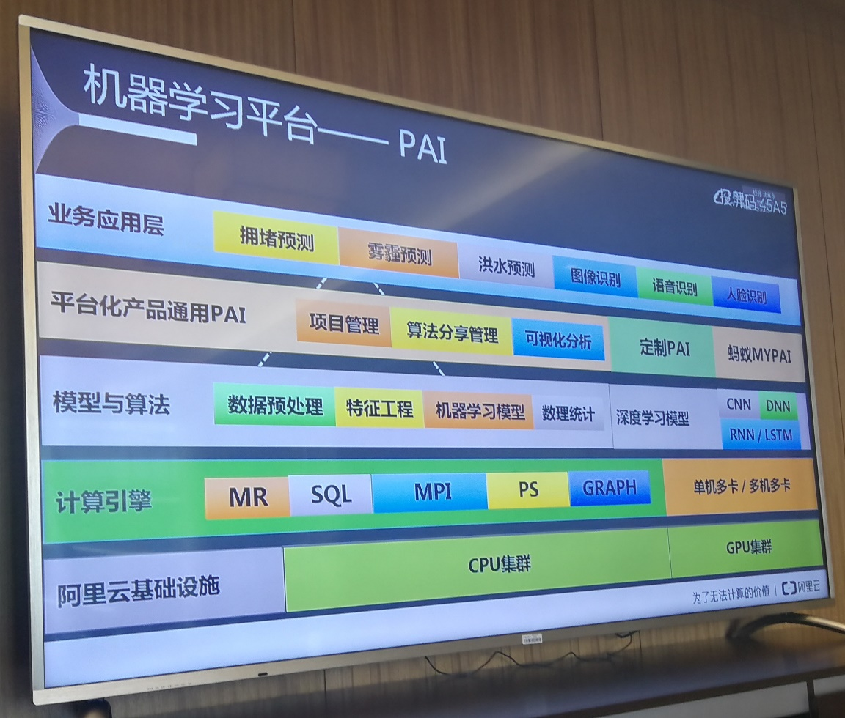

图16 阿里云机器学习平台——PAI（2017年6月拍摄）

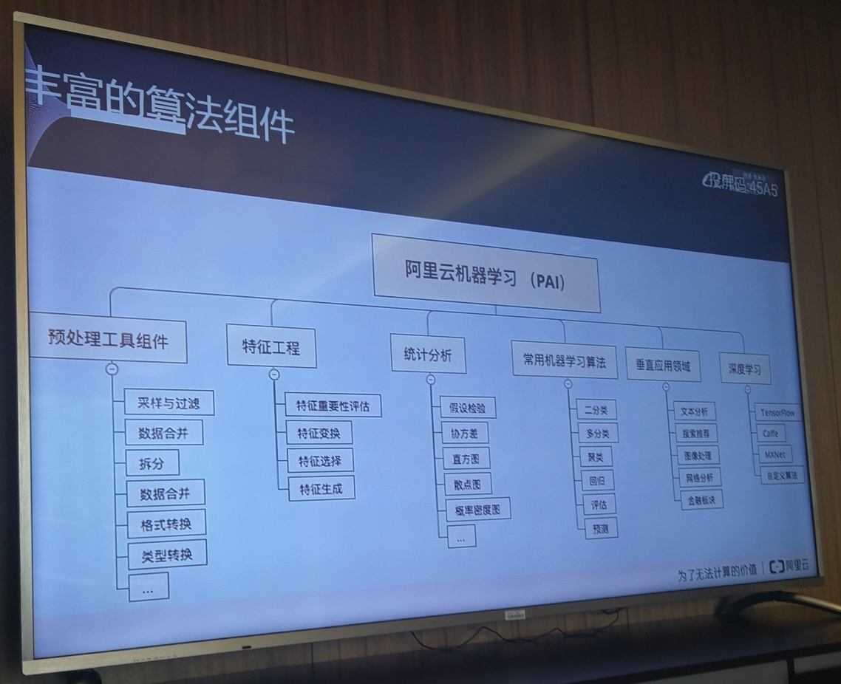

图17 阿里云机器学习算法组件（2017年6月拍摄）

1. 百度大数据与人工智能平台
2. 百度天算

天算（<https://cloud.baidu.com/solution/bigdata.html>）是百度云提供的大数据和人工智能平台，提供了完备的大数据托管服务、智能API以及众多业务场景模板，帮助用户实现智能业务，引领未来。

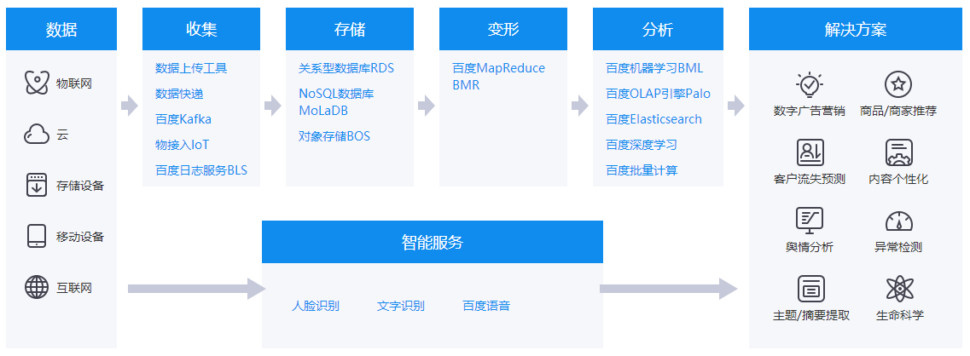

图18 百度天算平台

（1）大数据服务

* 百度MapReduce BMR：提供全托管的Hadoop/Spark计算集群服务，助力客户快速具备海量数据分析和挖掘能力。
* 百度机器学习BML：一个云端托管的分布式机器学习平台，提供特征工程、统计、训练、评估、预测和模型发布等功能，覆盖机器学习全流程，高效易用，助力客户轻松挖掘数据金矿。
* 百度OLAP引擎Palo：全托管的PB级别的MPP架构数据仓库服务，以较低的成本提供在大数据集上的多维分析和报表查询功能。ETL后的结构化数据导入到Palo中，便可以使用业界主流的BI工具进行实时分析和可视化展示，探索数据价值。
* 百度深度学习：一款面向海量数据的深度学习平台。平台基于PaddlePaddle/TensorFlow开源计算框架，支持GPU运算，依托百度云分布式技术，为深度学习技术的研发和应用提供可靠性高、扩展灵活的云端托管服务。
* 百度Kafka：基于Apache Kafka的分布式、高可扩展、高通量的消息托管服务。
* 百度日志服务BLS：百度云提供的日志收集与投递服务，依托云计算与大数据的技术优势，您只需简单地部署配置，面对海量日志亦可手到擒来，低成本、高效率地实现日志的采集、聚合与传输，轻松应对设备运维管理、商业趋势洞察、安全监控审计等业务场景。
* 百度批量计算：一种高效运行大规模并行作业的分布式云计算服务。百度批量计算可支持海量规模的并发作业，系统自动完成数据加载和作业调度、并弹性缩放计算资源。
* 百度Big SQL：通过SQL接口实现超大规模（TB级至PB级）结构化与非结构化数据集上的即席查询，洞察行业实现智能商业，而无须担心集群与运维。
* 百度Elasticsearch：开源的全文检索和分析引擎Elasticsearch的托管服务，提供自动运维和调优，减少客户自行管理基础设施的开销，并完全兼容开源接口，便于您现有业务零成本迁移。

（2）智能服务

* 人脸识别：基于业界领先的智能人脸分析算法，提供人脸检测、人脸识别、关键点定位、属性识别和活体检测等一整套技术方案。
* 文字识别：依托业界领先的深度学习技术，提供了自然场景下整图文字检测、定位、识别等功能。文字识别的结果可以用于翻译、搜索、TTS等代替用户输入的场景。
* 百度语音：提供语音识别、语音合成、语音唤醒等功能。

（3）解决方案

* 日志分析：依托百度云的大数据分析产品，提供日志分析托管服务，省去开发、部署以及运维的成本，可以聚焦于如何利用日志分析结果做出更好的决策。
* 数字营销：依托百度对数字营销服务市场多年的运营经验和技术积累，帮助搜索推广服务商及程序化交易生态中各类客户提升营销效率，实现用户数与收入的双重增长。
* 智能推荐：依托百度在多种推荐场景上的技术积累和丰富的用户画像数据，为广大企业提供有效、易用的智能推荐服务，快速提升业务目标。
* 舆情分析：为政府、广电媒体、舆情服务商、企业提供实时舆情数据订阅，智能语义分析，百度搜索指数及全网用户画像等功能，帮助客户实现个性化深度定制舆情系统，把握时事脉搏。
* 生命科学：帮助生物信息领域用户存储海量的数据，并调度强大的计算资源来进行基因组、蛋白质组等大数据分析。

1. 百度AI开放平台

百度AI开放平台（<http://ai.baidu.com/>）主要由三个部分构成，即人工智能的算法（百度AI开放平台已建成全球最大规模的神经网络，拥有万亿级的参数、千亿样本、千亿特征训练）、计算能力（拥有数十万台服务器和中国最大的GPU集群）和大数据（全网万亿网页、数十亿级搜索数据、百亿级图像视频数据、百亿级定位数据）。平台提供语音技术、图像技术、视频技术、自然语言处理、知识图谱、深度学习、数据智能、增强现实等全球领先的AI服务。

* 语音技术：语音识别、语音合成、语音唤醒。
* 图像技术：文字识别、人脸识别、图像审核。
* 视频技术：视频内容分析、视频封面选图、视频对比检索、视频内容审核。
* 自然语言处理：语言处理基础技术、理解与交互技术UNIT、百度翻译开放平台。
* 知识图谱：结构化数据抽取、知识图谱Schema。
* 深度学习：PaddlePaddle。
* 数据智能：数据存储与分析、数据统计与应用、受众定位与触达、营销辅助分析、风控与反欺诈、舆情监控分析。
* 增强现实：百度AR平台。

1. 腾讯“数智方略”

2016年7月5日，在腾讯“云+未来”峰会上，腾讯云正式宣布将腾讯大数据能力全面开放，推出一站式数据分析与挖掘服务平台——数智方略。数智方略覆盖基础平台、通用数据应用及行业解决方案在内的40余个产品及服务。2017年6月22日，腾讯云宣布升级推出数智方略2.0，为“智能云”提供基础技术平台到服务领域的全链路解决方案，是针对终端用户的端到端、低门槛易用的大数据平台，可以让数据科学家更加专注在算法层面。

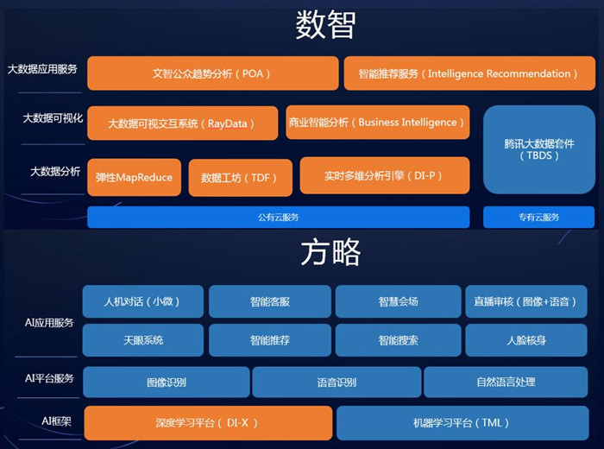

图19 腾讯数智方略平台

腾讯云依托资源（基于腾讯强大的AI基础计算平台）、数据（基于微信、游戏等众多互联网业务的海量数据）、算法（基于腾讯优图实验室、微信智能语音团队、腾讯AI lab等），从实践中获得计算机视觉、智能语音识别、自然语音处理三大优势能力，最终提供下述服务：智能语音服务、文智自然语言处理、社交娱乐应用的AI解决方案、安防监控解决方案“天眼系统”、智慧法院解决方案等服务。

* 智能语音服务基于数十万小时标注语音数据，提供涵盖了语音转文字、语音合成、声纹识别、音频鉴黄、关键词检索、情绪识别等13种能力，已经服务超过300家企业，主要应用在直播点播、金融、法院、教育、医疗、社交等领域。
* 社交娱乐应用的AI解决方案应用在直播行业，可通过对声音识别，召回敏感词完成直播内容的合规性审核和图像的识别，在图像方面可有效检出涉黄图片，准确率达99.9%。
* 智慧法院的人工智能解决方案，主要从现场庭审和远程庭审两方面提升人民法院的效率和服务，目前已经在北京，江苏、广东、山东等全国十余个省份的法院展开应用。

1. 华为FusionInsight平台

FusionInsight是华为面向众多行业客户推出的，基于Apache开源社区软件进行功能增强的企业级大数据存储、查询和分析的统一平台。它以海量数据处理引擎和实时数据处理引擎为核心，并针对金融、运营商等数据密集型行业的运行维护、应用开发等需求，打造了敏捷、智慧、可信的平台软件、建模中间件及OM系统，让企业可以更快、更准、更稳的从各类繁杂无序的海量数据中发现全新价值点和企业商机。

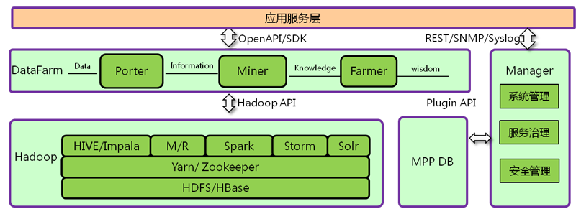

图20 华为FusionInsight平台架构（摘自官网）

以下是2017年6月调研情况：

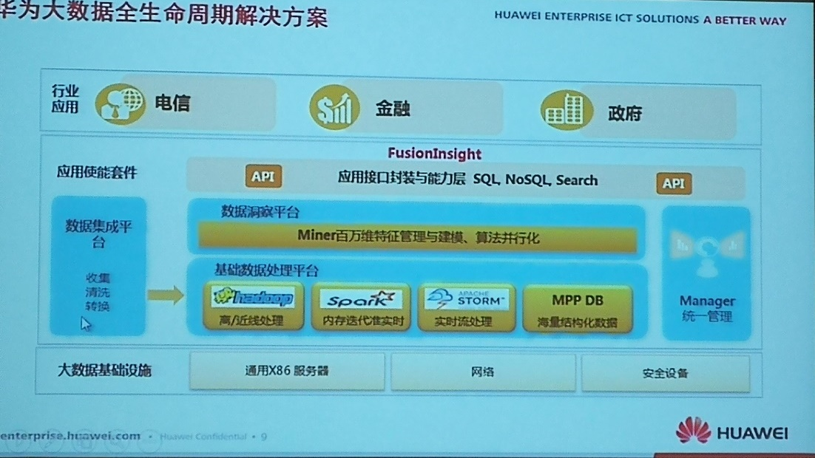

图21 华为大数据全生命周期解决方案（2017年6月拍摄）

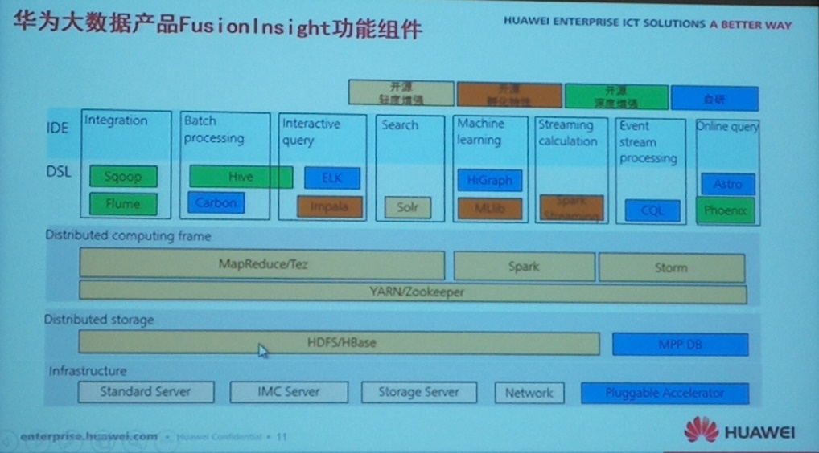

图22 华为大数据产品FusionInsight功能组件（2017年6月拍摄）

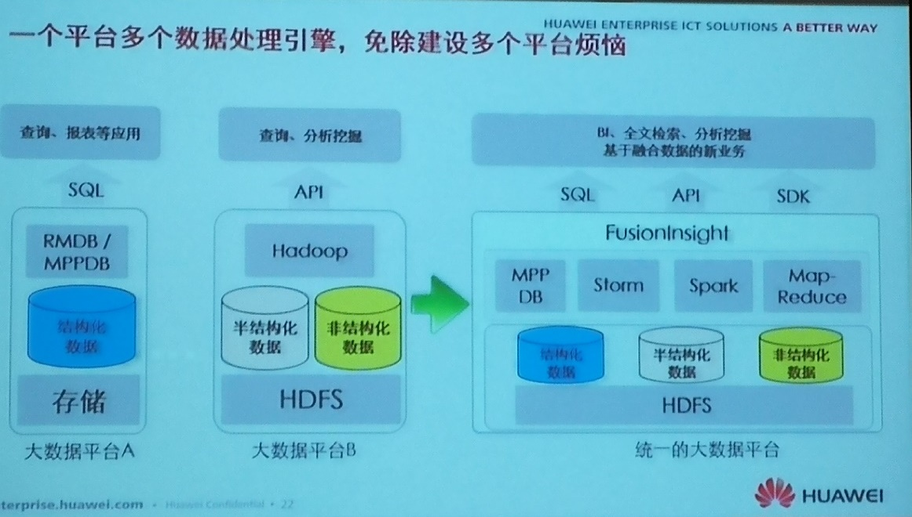

图23 异构数据处理引擎混搭架构（2017年6月拍摄）

1. 新华三DataEngine大数据平台

2017年4月，新华三DataEngine 1.0大数据平台在“H3C Navigate 2017”领航者峰会上正式发布，这意味着新华三正式进军大数据行业，“三大一云”的新IT战略(大数据、大安全、大互联和云计算)已经全面完成布局。

新华三大数据产品主要包括三类：NaviData大数据一体机、DataEngine大数据平台、行业大数据应用。



图24 新华三大数据产品谱系



图25 H3C DataEngine大数据平台架构



图26 H3C DataEngine细分组件产品

1. 浪潮大数据
2. 云海Insight大数据平台

浪潮云海Insight大数据平台包含Hadoop、Spark、MPP等多种主流架构数据套件，提供海量异构数据集成、高效存储、多场景计算和分析挖掘等功能，满足多种数据类型（结构化、半结构化、非结构化数据）和多种计算场景（离线、近线、实时）的不同需求，助力客户实现传统产业数字化、智能化，做大做强数字经济，为产业转型升级提供新动力。

云海Insight大数据平台架构如图27所示。

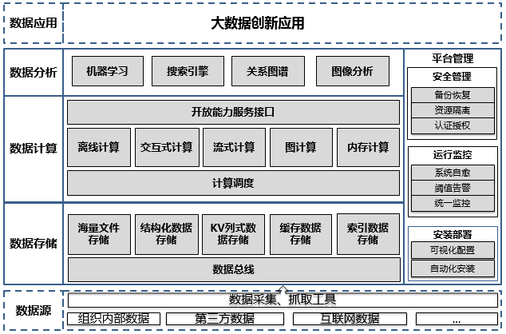

图27 浪潮云海Insight大数据平台架构

（1）数据集成

平台提供统一的数据总线，在传统ETL基础上增加对非结构化数据、流数据、互联网数据的支撑，通过实时数据预处理或单独的批量数据离线处理脚本，协同完成数据清洗、去重、打标签、索引化、分发等大数据管控和治理体系建设。

对于结构化数据，从技术实现上通过ETL工具进行数据抽取。ETL工具基于业界主流的ETL产品Kettle来实现，支持Oracle、DB2、SQLServer、MySQL等主流关系数据库之间以及到Hadoop的数据抽取。

对于非结构化数据，特别是互联网相关的网页、图片、视音频文件等，主要通过分布式网络爬虫进行获取。该工具可实现数据采集、抽取、预处理、任务优先级、任务监控的灵活定义。通过与后端的智能化语义处理模块协作，可实现高效的互联网数据价值挖掘。

（2）数据存储

在数据存储层面，传统数据存储方式在海量数据场景下，存储容量和读取性能方面都出现了明显的弊端。数据通过不同渠道采集集成到平台之后，平台根据数据的使用方式等采用不同的分布式存储技术进行存储，使得整个数据环境具备高度的伸缩性和扩展性，满足未来快速增长的数据规模，并充分保证数据存储方式的合理性及将来软硬件的扩展能力。除了原来的关系型数据库外，大数据平台还提供如下几种存储方式：

基于HDFS分布式文件系统，将数据的访问和存储分布在大量服务器之中，在可靠的多备份存储的同时还能将访问分布在集群中的各个服务器之上，通过分布式存储实现数据的冗余备份，并提升大数据的访问存取性能，高效低成本地应对海量非结构化数据和不需要关联分析、Ad-hoc查询较少的低价值密度结构化数据的存储和处理工作。

KV列式数据存储，针对结构化数据，采用与传统数据库类似的设计模型，支持数字、字符串、二进制和布尔值等多种数据类型；针对半结构化数据,则允许开发者自定义数据模型，提供多种数据访问方式，助力高性能应用程序的开发。

MPP数据存储，针对海量数据提供无共享的分布式、并行处理架构，应对海量结构化数据的分析挖掘场景。

内存数据存储，基于全部数据都在内存中的，在、快速算法、并行操作方面进行了相应的改进，数据处理速度比的数据处理速度提升很多，可以有效解决数据访问延时的问题。

（3）数据计算

* 集成丰富的计算框架

大规模数据计算与处理的场景复杂，性能要求高，因此需要采用分布式、可扩展的计算和调度架构。

离线计算：需要调度批量任务来操作大规模静态数据，适合实时性要求不高的场景。通过将一个大的任务划分成多个部分，分别交给多个计算节点进行处理，综合得到最终结果。

流式计算：在数据的有效时间内获取其价值，是流式计算系统的首要设计目标。因此，当数据到来后将立即对其进行计算，而不再对其进行缓存等待后续全部数据到来再进行计算。流式计算主要用在搜索、实时监控统计、实时推荐、垃圾邮件处理等场景。

内存计算：面对海量信息，传统的技术架构中需要读取数据，然后再进行运算，性能和效率不尽人如意。而内存计算，将整个数据放入内存，使每个事务在执行过程中没有I/O，相对于磁盘操作，内存的数据读写速度要高出几个数量级。

图计算：分布式图计算通过抽象分布式存储、并行计算等复杂问题，高效处理巨型图的各种操作，从噪音很多的海量数据中抽取有用的信息，可以挖掘人、物和实体之间的潜在、不易观察的行为和联系。

* 统一的调度管理和标准的开放服务

通过统一的资源调度框架，实现了不同计算框架的共享管理模式。通过这种共享管理模式，可以感知各节点的资源情况和计算压力，自动平衡和调度计算任务，大大提升计算效率和资源有效利用率。

提供标准的开放服务接口，将计算能力以服务接口的方式进行暴露，易理解、易调用。服务接口提供统一认证，接口调用时需提供账号、密码、密钥、租户信息等获取访问凭证，保证服务访问的安全可靠。

（4）数据分析挖掘

* 智能搜索

智能搜索引擎把相关的结构化和非结构化内容信息抽取出来并进行建模，经过中文分词技术建立起索引，让用户通过搜索快速地访问到这些信息，并能做到根据用户的个性化做出合理的排序结果。

* 机器学习

机器学习提供方便易用的交互式界面，帮助使用者进行离线批量预测或在线实时预测。预测过程运行在分布式系统中，基于内存进行迭代式计算，可以对海量数据进行预测，具备极强的扩展性，每天可以生成十几亿条预测结果。针对预制值，允许人工调整和修改，以确保数据读取的准确性，从而提升预测命中率。支持成熟、丰富的数据挖掘算法，可以生成分类、聚集、回归模型，适应在多种行业的机器学习场景。

1. 天元数据

浪潮集团基于建立一个全国最大数据资源与创新平台的愿景，推出“天元数据”（<https://www.tdata.cn/>），同时，吸纳卓创资讯、基因云馆、北京宜信致诚、广州云润等上百个大数据企业，打造了国内最大的数据生态联盟：天元数盟。

目前，天元数据持续整合浪潮自有数据、政府公开数据以及联盟伙伴数据，数据商品涵盖了线上零售、生活服务、企业数据、农业、资源能化等10大类，促进了大数据商品的流通和交易，为政府、企业及个人提供门类齐全、安全可靠的数据资源。在2016中国大数据大会暨大数据年度盛典上，浪潮大数据荣获2016年度中国大数据创新企业奖，天元数据荣获2016年度中国大数据明星平台奖。

浪潮大数据经过数年实践，探索出了“公司+创客”模式，通过天元数据和天元数据库为A创客（从事大数据应用开发）进行数据应用提供大数据处理平台、实时数据API、云服务，以及创业项目包装推广等扶持；为B类创客（从事大数据采集）采集数据提供数据采集工具、数据处理平台，并向B创客购买采集后的数据，从而给予大数据产业的创业者更多支持，逐渐形成完善的大数据双创生态。

1. 中国联通公共创新大数据能力开放平台

中国联通研究院下设大数据研究中心，主要负责大数据方向策略研究，大数据开源新技术研究，大数据平台研发及其产、学、研、用合作开放孵化，大数据行业应用，大数据支撑主营业务营收，平台级软件开发及其相关工作。大数据研究中心是大数据流通与交易技术国家工程实验室跨行业数据融合交换研究中心的主要承担者，完成集团大数据平台能力的研发、研究与验证，支撑集团大数据能力平台建设；同时开展跨行业大数据创新应用和场景的孵化，形成大数据创新应用场景向生产运营系统引流。目前中心设立以下研究室：

* 大数据技术研究室——推进大数据新技术、新模式的基础研究和验证，形成论文、软文、专利、报告、PoC演示等成果。
* 大数据应用模型研发室——与集团内部的前端业务部门、后端IT支撑部门，以及外部在大数据领域领先的企业、高校、研究机构等开展合作，开展产学研用互动，研发基于跨领域融合数据的应用模型，探索和孵化大数据创新应用，形成面向行业应用拓展的解决方案和基于融合数据的创新大数据应用产品，引流至生产平台。
* 大数据软件研发室——吸纳IT技术架构、大数据新技术等方面的研发成果，研发大数据平台、大数据解决方案展示平台等软件系统，形成B版本的软件系统；集成大数据孵化平台的各种能力，统一交付到产品经营者、创业孵化团队等组织，并完成相关IT系统软件开发。
* IT技术架构研发室——在IT架构领域不断引入新技术，完成新技术选型、引入和架构适配的研发验证工作，形成面向IT系统的自有软件版本。

目前，中国联通面向科研院所、创新企业、行业大数据应用合作者推出公共创新大数据能力开放平台（<http://das.bigdata.unicomlabs.cn:9090/>），旨在探索“数据+能力”的大数据开放合作模式，激发社会创新活力，汇聚社会化资源，共创“众创、众筹”的大数据价值创造新模式。

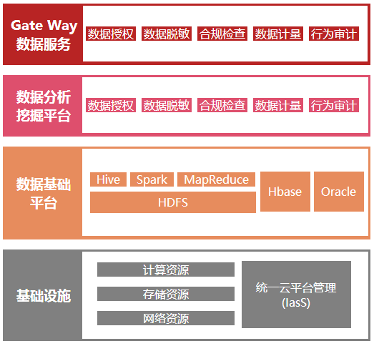

图28 中国联通公共创新大数据能力开放平台

（1）数据存储-2种：高速的多源异构存储能力：传统关系型数据存储、HDFS支撑的多类型文件的存储。

（2）数据加工-5种：MR/HSQL/Spark/Kafka/SQL等5种数据加工脚本，提供完整的数据采集、清洗、抽取、转换、装载和关联的能力。

（3）数据建模-5种：指标+规则、标签+规则、关联分析、数据挖掘、R等5类建模能力。

（4）数据审核-3种：提供符合工信部关于个人通信数据隐私保护的9项规定，实现结果数据的授权、脱敏、合规检查、计量和行为审计能力。

1. 58同城

58同城大数据平台架构分为三层：数据基础平台层、数据应用平台层、数据应用层，还有两列监控与报警和平台管理。

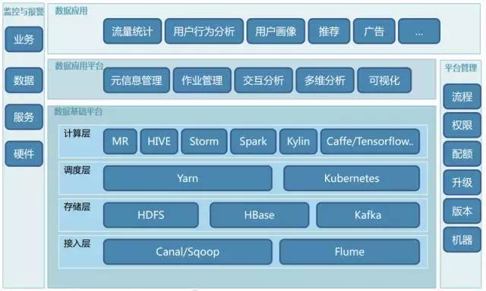

图29 58同城大数据平台架构

数据基础平台层分为四个子层：

* 接入层：包括了Canal/Sqoop（主要解决数据库数据接入问题）、还有大量的数据采用Flume解决方案；
* 存储层：HDFS（文件存储）、HBase（KV存储）、Kafka（消息缓存）；
* 调度层：采用Yarn的统一调度以及Kubernetes的基于容器的管理和调度的技术；
* 计算层：典型的所有计算模型的计算引擎，包含了MR、HIVE、Storm、Spark、Kylin以及深度学习平台比如Caffe、Tensorflow等等。

数据应用平台主要包括以下功能：

* 元信息管理，还有针对所有计算引擎、计算引擎job的作业管理，之后就是交互分析、多维分析以及数据可视化的功能。
* 数据业务，比如说流量统计、用户行为分析、用户画像、搜索、广告等等。针对业务、数据、服务、硬件要有完备的检测与报警体系。
* 平台管理方面，需要对流程、权限、配额、升级、版本、机器要有很全面的管理平台。

1. 启明星辰/杭州合众

启明星辰信息技术集团股份有限公司成立于1996年，由留美博士严望佳女士创建，是国内最具实力的、拥有完全自主知识产权的网络安全产品、可信安全管理平台、安全服务与解决方案的综合提供商。2010年6月23日，启明星辰在深交所中小板正式挂牌上市。目前，启明星辰已对网御星云、杭州合众、书生电子进行了全资收购，旗下投资参股公司达到30多家。

杭州合众数据技术有限公司（前身为杭州合众信息技术股份有限公司）是国内著名的专门从事数据交换、数据处理、大数据分析及大数据安全类产品研发的生产商和系统集成商。公司成立于2003年，并于2014年加入国内信息安全领域领军企业——北京启明星辰集团。目前，公司在大数据领域布局两大战略方向：大数据基础开发平台和安全大数据。

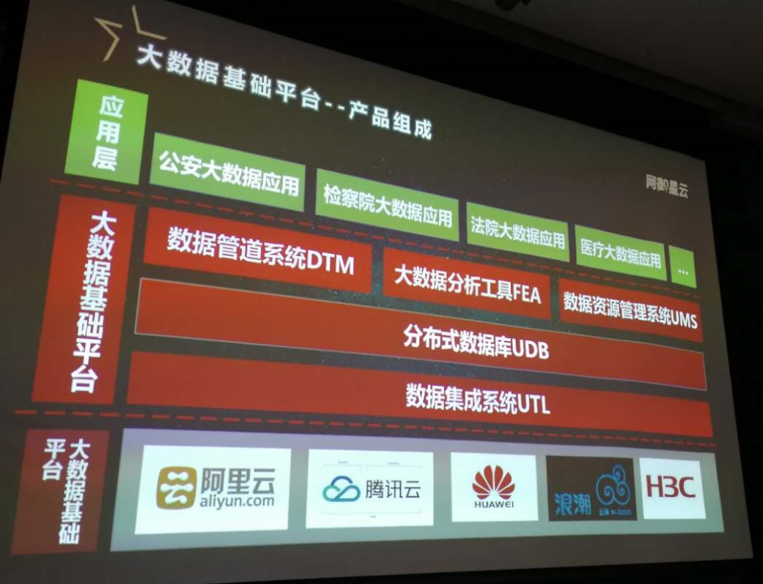

图30 杭州合众大数据基础平台

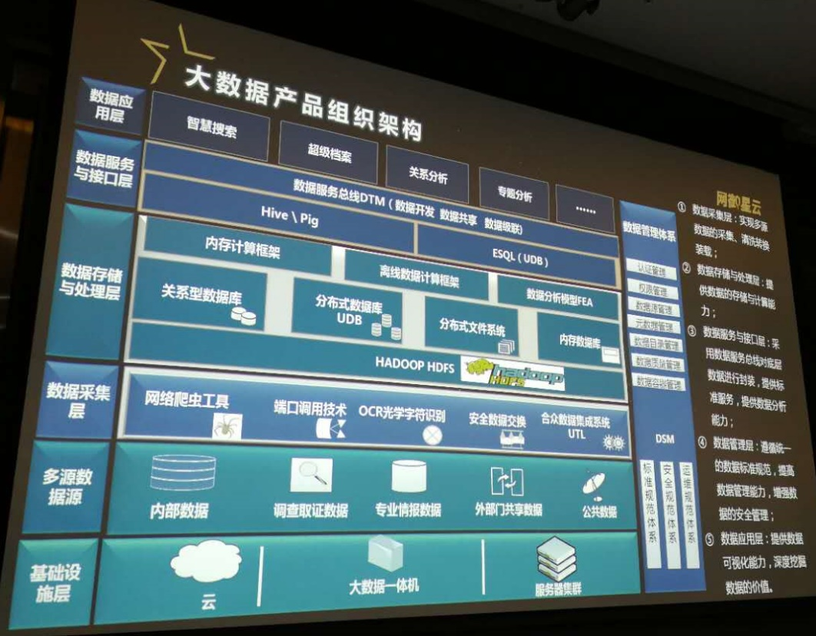

图31 杭州合众大数据产品组织架构

一站式大数据敏捷分析平台（<http://openfea.cn/>）融合了内存计算、集群运算、机器学习、交互分析、可视化分析等技术，涵盖数据收集、数据探索、构建模型、模型发布等功能，分析性能卓越，使用简便，无需复杂编程即可快速实现大数据分析，助力数据分析师激扬数据，塑造业务标杆。

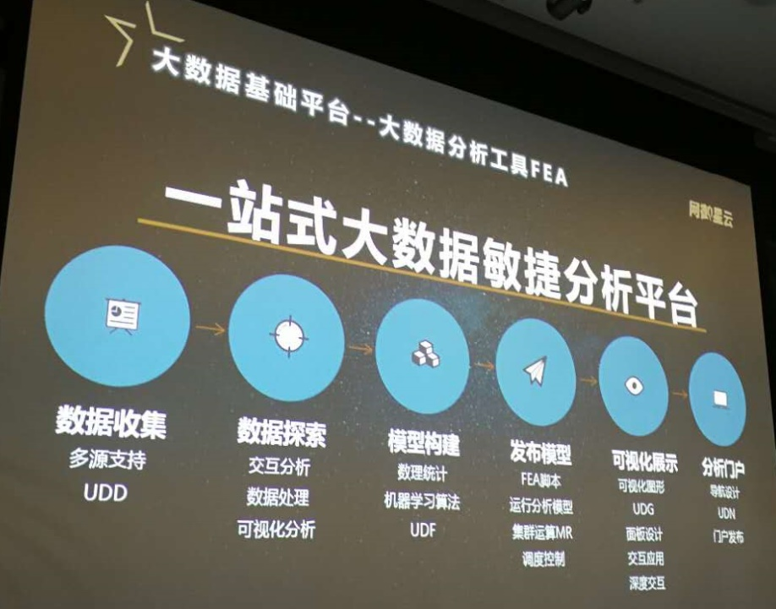

图32 杭州合众一站式大数据敏捷分析平台

用户行为分析系统用于监测和分析合法用户的异常操作行为，预测可能发生的数据泄露威胁，并及时预警。

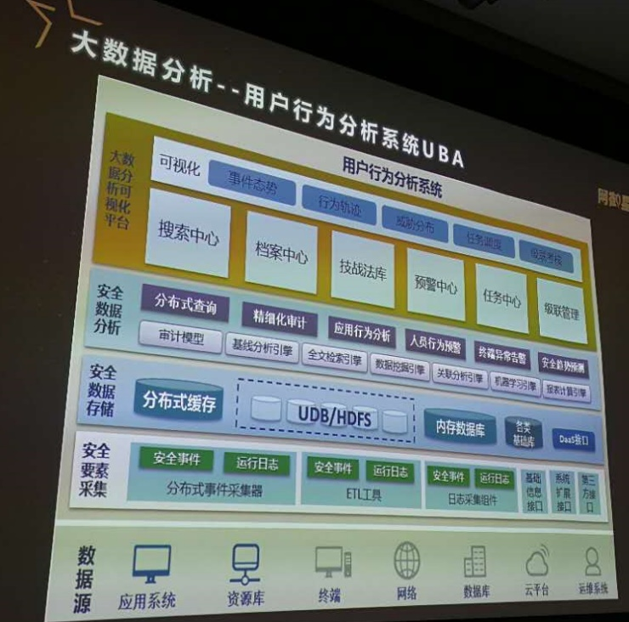

图33 杭州合众用户行为分析系统

1. 行业大数据平台架构
2. 北京市政务大数据平台

政务大数据按照政府管理的数据来源和种类，可以分为以下三类：

* 第一类业务数据：业务办理过程中采集和产生的数据。
* 第二类民意社情数据：对社会企业个人对象进行统计调查获得的数据。
* 第三类环境数据：通过物理设备采集获得的气象、环境、影像等数据。

政务大数据与其他领域大数据相比具有鲜明的特点：

* 体积大，增速高：涵盖经济社会管理的方方面面，数据积累量巨大。每年处理的数据呈指数级增长。
* 种类多，价值大：以宏观经济基础数据为例：涵盖经济、社会、医疗、环境、工农业、教育、旅游等社会关键领域数据，具有极为重要的社会和经济价值。
* 垄断性，难获得：政府部门及公共企事业单位采集数据有些是专营的业务，一般企业是采不到，也买不到。

北京市政务大数据平台功能架构如图34所示。

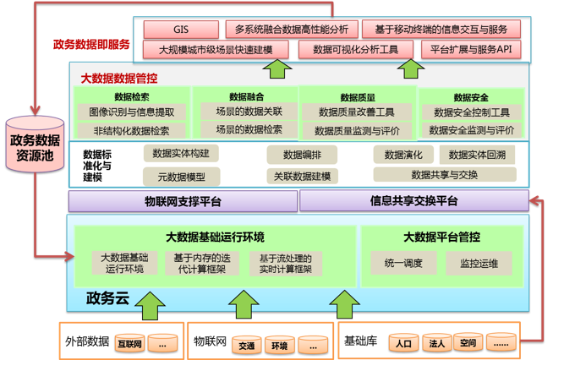

图34 北京市政务大数据平台功能架构

平台核心功能包括：

（1）对基础库、物理网数据、互联网数据、外部数据的采集汇聚。

（2）对以结构化数据为主的传统数据的融合处理。

（3）对以非结构化、音频、视频等新型数据为主的融合处理。

（4）数据质量管控：通过对数据，应用，系统综合管理，构建标准化、流程化、自动化、一体化的数据管理体系。

（5）跨平台调度实现数据互联互通，统一管控：提供跨系统跨平台的任务调度功能，与各子系统紧密接合，涵盖接口子系统、维护子系统、云平台、接口分发平台。

北京市政务大数据平台的技术架构采用混搭模式，一方面不改变已有的原始数据的存储和管理方式，另一方面，采用大数据新技术处理原有方式不能处理的新数据，重点是对非结构化、新数据的处理。

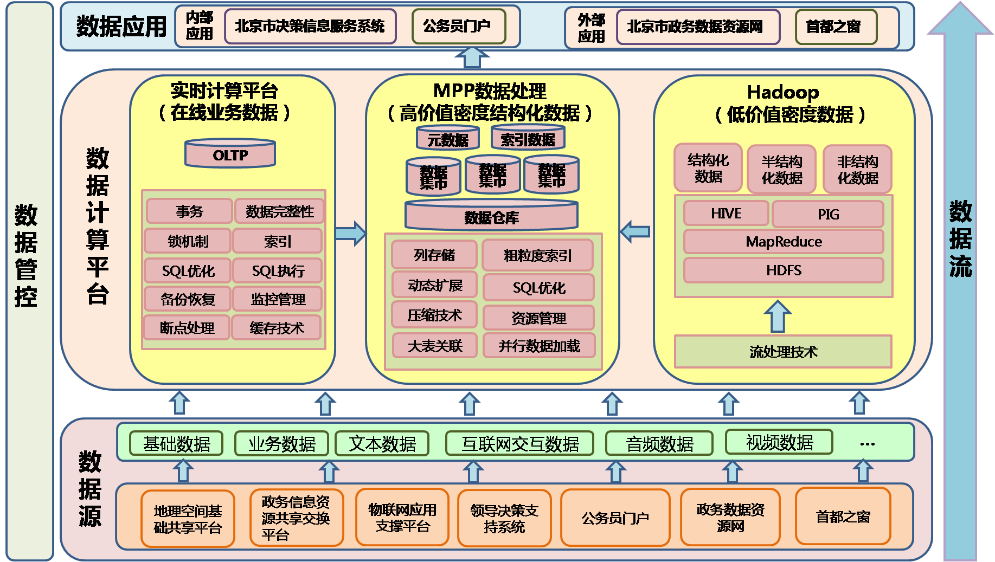

图35 北京市政务大数据平台“混搭式”技术架构

附件1：大数据平台主流工具/组件列表

来源：[The Hadoop Ecosystem Table](https://hadoopecosystemtable.github.io/)

1. 分布式文件系统

| **Index** | **Name** | **Description** | **Links** |
| --- | --- | --- | --- |
|  | **Apache HDFS** | The Hadoop Distributed File System (HDFS) offers a way to store large files across multiple machines. Hadoop and HDFS was derived from Google File System (GFS) paper. Prior to Hadoop 2.0.0, the NameNode was a single point of failure (SPOF) in an HDFS cluster. With Zookeeper the HDFS High Availability feature addresses this problem by providing the option of running two redundant NameNodes in the same cluster in an Active/Passive configuration with a hot standby. | [1. hadoop.apache.org](http://hadoop.apache.org/)  [2. Google FileSystem - GFS Paper](http://research.google.com/archive/gfs.html)  [3. Cloudera Why HDFS](http://blog.cloudera.com/blog/2012/07/why-we-build-our-platform-on-hdfs/)  [4. Hortonworks Why HDFS](http://hortonworks.com/blog/thinking-about-the-hdfs-vs-other-storage-technologies/) |
|  | **Red Hat GlusterFS** | GlusterFS is a scale-out network-attached storage file system. GlusterFS was developed originally by Gluster, Inc., then by Red Hat, Inc., after their purchase of Gluster in 2011. In June 2012, Red Hat Storage Server was announced as a commercially-supported integration of GlusterFS with Red Hat Enterprise Linux. Gluster File System, known now as Red Hat Storage Server. | [1. www.gluster.org](http://www.gluster.org/)  [2. Red Hat Hadoop Plugin](http://www.redhat.com/about/news/archive/2013/10/red-hat-contributes-apache-hadoop-plug-in-to-the-gluster-community) |
|  | **Quantcast File System QFS** | QFS is an open-source distributed file system software package for large-scale MapReduce or other batch-processing workloads. It was designed as an alternative to Apache Hadoop’s HDFS, intended to deliver better performance and cost-efficiency for large-scale processing clusters. It is written in C++ and has fixed-footprint memory management. QFS uses Reed-Solomon error correction as method for assuring reliable access to data. Reed–Solomon coding is very widely used in mass storage systems to correct the burst errors associated with media defects. Rather than storing three full versions of each file like HDFS, resulting in the need for three times more storage, QFS only needs 1.5x the raw capacity because it stripes data across nine different disk drives. | [1. QFS site](https://www.quantcast.com/engineering/qfs/)  [2. GitHub QFS](https://github.com/quantcast/qfs)  [3. HADOOP-8885](https://issues.apache.org/jira/browse/HADOOP-8885) |
|  | **Ceph Filesystem** | Ceph is a free software storage platform designed to present object, block, and file storage from a single distributed computer cluster. Ceph's main goals are to be completely distributed without a single point of failure, scalable to the exabyte level, and freely-available. The data is replicated, making it fault tolerant. | [1. Ceph Filesystem site](http://ceph.com/ceph-storage/file-system/)  [2. Ceph and Hadoop](http://ceph.com/docs/next/cephfs/hadoop/)  [3. HADOOP-6253](https://issues.apache.org/jira/browse/HADOOP-6253) |
|  | **Lustre file system** | The Lustre filesystem is a high-performance distributed filesystem intended for larger network and high-availability environments. Traditionally, Lustre is configured to manage remote data storage disk devices within a Storage Area Network (SAN), which is two or more remotely attached disk devices communicating via a Small Computer System Interface (SCSI) protocol. This includes Fibre Channel, Fibre Channel over Ethernet (FCoE), Serial Attached SCSI (SAS) and even iSCSI. With Hadoop HDFS the software needs a dedicated cluster of computers on which to run. But folks who run high performance computing clusters for other purposes often don't run HDFS, which leaves them with a bunch of computing power, tasks that could almost certainly benefit from a bit of map reduce and no way to put that power to work running Hadoop. Intel's noticed this and, in version 2.5 of its Hadoop distribution that it quietly released last week, has added support for Lustre: the Intel® HPC Distribution for Apache Hadoop* Software, a new product that combines Intel Distribution for Apache Hadoop software with Intel® Enterprise Edition for Lustre software. This is the only distribution of Apache Hadoop that is integrated with Lustre, the parallel file system used by many of the world's fastest supercomputers | [1. wiki.lustre.org/](http://wiki.lustre.org/)  [2. Hadoop with Lustre](http://wiki.lustre.org/index.php/Running_Hadoop_with_Lustre)  [3. Intel HPC Hadoop](http://hadoop.intel.com/products/distribution) |
|  | **Alluxio** | Alluxio, the world’s first memory-centric virtual distributed storage system, unifies data access and bridges computation frameworks and underlying storage systems. Applications only need to connect with Alluxio to access data stored in any underlying storage systems. Additionally, Alluxio’s memory-centric architecture enables data access orders of magnitude faster than existing solutions.  In big data ecosystem, Alluxio lies between computation frameworks or jobs, such as Apache Spark, Apache MapReduce, or Apache Flink, and various kinds of storage systems, such as Amazon S3, OpenStack Swift, GlusterFS, HDFS, Ceph, or OSS. Alluxio brings significant performance improvement to the stack; for example, Baidu uses Alluxio to improve their data analytics performance by 30 times. Beyond performance, Alluxio bridges new workloads with data stored in traditional storage systems. Users can run Alluxio using its standalone cluster mode, for example on Amazon EC2, or launch Alluxio with Apache Mesos or Apache Yarn.  Alluxio is Hadoop compatible. This means that existing Spark and MapReduce programs can run on top of Alluxio without any code changes. The project is open source (Apache License 2.0) and is deployed at multiple companies. It is one of the fastest growing open source projects. With less than three years open source history, Alluxio has attracted more than 160 contributors from over 50 institutions, including Alibaba, Alluxio, Baidu, CMU, IBM, Intel, NJU, Red Hat, UC Berkeley, and Yahoo. The project is the storage layer of the Berkeley Data Analytics Stack (BDAS) and also part of the Fedora distribution. | [1. Alluxio site](http://www.alluxio.org/) |
|  | **GridGain** | GridGain is open source project licensed under Apache 2.0. One of the main pieces of this platform is the In-Memory Apache Hadoop Accelerator which aims to accelerate HDFS and Map/Reduce by bringing both, data and computations into memory. This work is done with the GGFS - Hadoop compliant in-memory file system. For I/O intensive jobs GridGain GGFS offers performance close to 100x faster than standard HDFS. Paraphrasing Dmitriy Setrakyan from GridGain Systems talking about GGFS regarding Tachyon:   * GGFS allows read-through and write-through to/from underlying HDFS or any other Hadoop compliant file system with zero code change. Essentially GGFS entirely removes ETL step from integration. * GGFS has ability to pick and choose what folders stay in memory, what folders stay on disc, and what folders get synchronized with underlying (HD)FS either synchronously or asynchronously. * GridGain is working on adding native MapReduce component which will provide native complete Hadoop integration without changes in API, like Spark currently forces you to do. Essentially GridGain MR+GGFS will allow to bring Hadoop completely or partially in-memory in Plug-n-Play fashion without any API changes. | [1. GridGain site](http://www.gridgain.org/) |
|  | **XtreemFS** | XtreemFS is a general purpose storage system and covers most storage needs in a single deployment. It is open-source, requires no special hardware or kernel modules, and can be mounted on Linux, Windows and OS X. XtreemFS runs distributed and offers resilience through replication. XtreemFS Volumes can be accessed through a FUSE component, that offers normal file interaction with POSIX like semantics. Furthermore an implementation of Hadoops FileSystem interface is included which makes XtreemFS available for use with Hadoop, Flink and Spark out of the box. XtreemFS is licensed under the New BSD license. The XtreemFS project is developed by Zuse Institute Berlin. The development of the project is funded by the European Commission since 2006 under Grant Agreements No. FP6-033576, FP7-ICT-257438, and FP7-318521, as well as the German projects MoSGrid, "First We Take Berlin", FFMK, GeoMultiSens, and BBDC. | [1. XtreemFS site](http://www.xtreemfs.org/) [2. Flink on XtreemFS](https://github.com/xtreemfs/xtreemfs/wiki/Apache-Flink-with-XtreemFS) [. Spark XtreemFS](https://github.com/xtreemfs/xtreemfs/wiki/Apache-Spark-with-XtreemFS) |

1. 分布式编程

| **Index** | **Name** | **Description** | **Links** |
| --- | --- | --- | --- |
|  | **Apache Ignite** | Apache Ignite In-Memory Data Fabric is a distributed in-memory platform for computing and transacting on large-scale data sets in real-time. It includes a distributed key-value in-memory store, SQL capabilities, map-reduce and other computations, distributed data structures, continuous queries, messaging and events subsystems, Hadoop and Spark integration. Ignite is built in Java and provides .NET and C++ APIs. | [1. Apache Ignite](http://ignite.apache.org/)  [2. Apache Ignite documentation](https://apacheignite.readme.io/) |
|  | **Apache MapReduce** | MapReduce is a programming model for processing large data sets with a parallel, distributed algorithm on a cluster. Apache MapReduce was derived from Google MapReduce: Simplified Data Processing on Large Clusters paper. The current Apache MapReduce version is built over Apache YARN Framework. YARN stands for “Yet-Another-Resource-Negotiator”. It is a new framework that facilitates writing arbitrary distributed processing frameworks and applications. YARN’s execution model is more generic than the earlier MapReduce implementation. YARN can run applications that do not follow the MapReduce model, unlike the original Apache Hadoop MapReduce (also called MR1). Hadoop YARN is an attempt to take Apache Hadoop beyond MapReduce for data-processing. | [1. Apache MapReduce](http://wiki.apache.org/hadoop/MapReduce/)  [2. Google MapReduce paper](http://research.google.com/archive/mapreduce.html)  [3. Writing YARN applications](http://hadoop.apache.org/docs/stable/hadoop-yarn/hadoop-yarn-site/WritingYarnApplications.html) |
|  | **Apache Pig** | Pig provides an engine for executing data flows in parallel on Hadoop. It includes a language, Pig Latin, for expressing these data flows. Pig Latin includes operators for many of the traditional data operations (join, sort, filter, etc.), as well as the ability for users to develop their own functions for reading, processing, and writing data. Pig runs on Hadoop. It makes use of both the Hadoop Distributed File System, HDFS, and Hadoop’s processing system, MapReduce. Pig uses MapReduce to execute all of its data processing. It compiles the Pig Latin scripts that users write into a series of one or more MapReduce jobs that it then executes. Pig Latin looks different from many of the programming languages you have seen. There are no if statements or for loops in Pig Latin. This is because traditional procedural and object-oriented programming languages describe control flow, and data flow is a side effect of the program. Pig Latin instead focuses on data flow. | [1. pig.apache.org/](https://pig.apache.org/)  [2.Pig examples by Alan Gates](https://github.com/alanfgates/programmingpig) |
|  | **JAQL** | JAQL is a functional, declarative programming language designed especially for working with large volumes of structured, semi-structured and unstructured data. As its name implies, a primary use of JAQL is to handle data stored as JSON documents, but JAQL can work on various types of data. For example, it can support XML, comma-separated values (CSV) data and flat files. A "SQL within JAQL" capability lets programmers work with structured SQL data while employing a JSON data model that's less restrictive than its Structured Query Language counterparts. Specifically, Jaql allows you to select, join, group, and filter data that is stored in HDFS, much like a blend of Pig and Hive. Jaql’s query language was inspired by many programming and query languages, including Lisp, SQL, XQuery, and Pig.  JAQL was created by workers at IBM Research Labs in 2008 and released to open source. While it continues to be hosted as a project on Google Code, where a downloadable version is available under an Apache 2.0 license, the major development activity around JAQL has remained centered at IBM. The company offers the query language as part of the tools suite associated with InfoSphere BigInsights, its Hadoop platform. Working together with a workflow orchestrator, JAQL is used in BigInsights to exchange data between storage, processing and analytics jobs. It also provides links to external data and services, including relational databases and machine learning data. | [1. JAQL in Google Code](https://code.google.com/p/jaql/)  [2. What is Jaql? by IBM](http://www-01.ibm.com/software/data/infosphere/hadoop/jaql/) |
|  | **Apache Spark** | Data analytics cluster computing framework originally developed in the AMPLab at UC Berkeley. Spark fits into the Hadoop open-source community, building on top of the Hadoop Distributed File System (HDFS). However, Spark provides an easier to use alternative to Hadoop MapReduce and offers performance up to 10 times faster than previous generation systems like Hadoop MapReduce for certain applications. Spark is a framework for writing fast, distributed programs. Spark solves similar problems as Hadoop MapReduce does but with a fast in-memory approach and a clean functional style API. With its ability to integrate with Hadoop and inbuilt tools for interactive query analysis (Shark), large-scale graph processing and analysis (Bagel), and real-time analysis (Spark Streaming), it can be interactively used to quickly process and query big data sets. To make programming faster, Spark provides clean, concise APIs in Scala, Java and Python. You can also use Spark interactively from the Scala and Python shells to rapidly query big datasets. Spark is also the engine behind Shark, a fully Apache Hive-compatible data warehousing system that can run 100x faster than Hive. | [1. Apache Spark](http://spark.apache.org/)  [2. Mirror of Spark on Github](https://github.com/apache/spark)  [3. RDDs - Paper](http://www.cs.berkeley.edu/~matei/papers/2012/nsdi_spark.pdf)  [4. Spark: Cluster Computing... - Paper](https://people.csail.mit.edu/matei/papers/2010/hotcloud_spark.pdf)  [Spark Research](http://spark.apache.org/research.html) |
|  | **Apache Storm** | Storm is a complex event processor (CEP) and distributed computation framework written predominantly in the Clojure programming language. Is a distributed real-time computation system for processing fast, large streams of data. Storm is an architecture based on master-workers paradigma. So a Storm cluster mainly consists of a master and worker nodes, with coordination done by Zookeeper.  Storm makes use of zeromq (0mq, zeromq), an advanced, embeddable networking library. It provides a message queue, but unlike message-oriented middleware (MOM), a 0MQ system can run without a dedicated message broker. The library is designed to have a familiar socket-style API. Originally created by Nathan Marz and team at BackType, the project was open sourced after being acquired by Twitter. Storm was initially developed and deployed at BackType in 2011. After 7 months of development BackType was acquired by Twitter in July 2011. Storm was open sourced in September 2011.  Hortonworks is developing a Storm-on-YARN version and plans finish the base-level integration in 2013 Q4. This is the plan from Hortonworks. Yahoo/Hortonworks also plans to move Storm-on-YARN code from github.com/yahoo/storm-yarn to be a subproject of Apache Storm project in the near future. Twitter has recently released a Hadoop-Storm Hybrid called “Summingbird.” Summingbird fuses the two frameworks into one, allowing for developers to use Storm for short-term processing and Hadoop for deep data dives,. a system that aims to mitigate the tradeoffs between batch processing and stream processing by combining them into a hybrid system. | [1. Storm Project/](http://storm-project.net/)  [2. Storm-on-YARN](https://hadoopecosystemtable.github.io/github.com/yahoo/storm-yarn) |
|  | **Apache Flink** | Apache Flink (formerly called Stratosphere) features powerful programming abstractions in Java and Scala, a high-performance runtime, and automatic program optimization. It has native support for iterations, incremental iterations, and programs consisting of large DAGs of operations. Flink is a data processing system and an alternative to Hadoop's MapReduce component. It comes with its own runtime, rather than building on top of MapReduce. As such, it can work completely independently of the Hadoop ecosystem. However, Flink can also access Hadoop's distributed file system (HDFS) to read and write data, and Hadoop's next-generation resource manager (YARN) to provision cluster resources. Since most Flink users are using Hadoop HDFS to store their data, it ships already the required libraries to access HDFS. | [1. Apache Flink incubator page](http://flink.incubator.apache.org/)  [2. Stratosphere site](http://stratosphere.eu/) |
|  | **Apache Apex** | Apache Apex is an enterprise grade Apache YARN based big data-in-motion platform that unifies stream processing as well as batch processing. It processes big data in-motion in a highly scalable, highly performant, fault tolerant, stateful, secure, distributed, and an easily operable way. It provides a simple API that enables users to write or re-use generic Java code, thereby lowering the expertise needed to write big data applications.  The Apache Apex platform is supplemented by Apache Apex-Malhar, which is a library of operators that implement common business logic functions needed by customers who want to quickly develop applications. These operators provide access to HDFS, S3, NFS, FTP, and other file systems; Kafka, ActiveMQ, RabbitMQ, JMS, and other message systems; MySql, Cassandra, MongoDB, Redis, HBase, CouchDB and other databases along with JDBC connectors. The library also includes a host of other common business logic patterns that help users to significantly reduce the time it takes to go into production. Ease of integration with all other big data technologies is one of the primary missions of Apache Apex-Malhar.  Apex, available on GitHub, is the core technology upon which DataTorrent's commercial offering, DataTorrent RTS 3, along with other technology such as a data ingestion tool called dtIngest, are based. | [1. Apache Apex from DataTorrent](https://www.datatorrent.com/apex/)  [2. Apache Apex main page](http://apex.incubator.apache.org/)  [3. Apache Apex Proposal](https://wiki.apache.org/incubator/ApexProposal) |
|  | **Netflix PigPen** | PigPen is map-reduce for Clojure which compiles to Apache Pig. Clojure is dialect of the Lisp programming language created by Rich Hickey, so is a functional general-purpose language, and runs on the Java Virtual Machine, Common Language Runtime, and JavaScript engines. In PigPen there are no special user defined functions (UDFs). Define Clojure functions, anonymously or named, and use them like you would in any Clojure program. This tool is open sourced by Netflix, Inc. the American provider of on-demand Internet streaming media. | [1. PigPen on GitHub](https://github.com/Netflix/PigPen) |
|  | **AMPLab SIMR** | Apache Spark was developed thinking in Apache YARN. However, up to now, it has been relatively hard to run Apache Spark on Hadoop MapReduce v1 clusters, i.e. clusters that do not have YARN installed. Typically, users would have to get permission to install Spark/Scala on some subset of the machines, a process that could be time consuming. SIMR allows anyone with access to a Hadoop MapReduce v1 cluster to run Spark out of the box. A user can run Spark directly on top of Hadoop MapReduce v1 without any administrative rights, and without having Spark or Scala installed on any of the nodes. | [1. SIMR on GitHub](http://databricks.github.io/simr/) |
|  | **Facebook Corona** | “The next version of Map-Reduce" from Facebook, based in own fork of Hadoop. The current Hadoop implementation of the MapReduce technique uses a single job tracker, which causes scaling issues for very large data sets. The Apache Hadoop developers have been creating their own next-generation MapReduce, called YARN, which Facebook engineers looked at but discounted because of the highly-customised nature of the company's deployment of Hadoop and HDFS. Corona, like YARN, spawns multiple job trackers (one for each job, in Corona's case). | [1. Corona on Github](https://github.com/facebookarchive/hadoop-20/tree/master/src/contrib/corona) |
|  | **Apache REEF** | Apache REEF™ (Retainable Evaluator Execution Framework) is a library for developing portable applications for cluster resource managers such as Apache Hadoop™ YARN or Apache Mesos™. Apache REEF drastically simplifies development of those resource managers through the following features:   * Centralized Control Flow: Apache REEF turns the chaos of a distributed application into events in a single machine, the Job Driver. Events include container allocation, Task launch, completion and failure. For failures, Apache REEF makes every effort of making the actual `Exception` thrown by the Task available to the Driver. * Task runtime: Apache REEF provides a Task runtime called Evaluator. Evaluators are instantiated in every container of a REEF application. Evaluators can keep data in memory in between Tasks, which enables efficient pipelines on REEF. * Support for multiple resource managers: Apache REEF applications are portable to any supported resource manager with minimal effort. Further, new resource managers are easy to support in REEF. * .NET and Java API: Apache REEF is the only API to write YARN or Mesos applications in .NET. Further, a single REEF application is free to mix and match Tasks written for .NET or Java. * Plugins: Apache REEF allows for plugins (called "Services") to augment its feature set without adding bloat to the core. REEF includes many Services, such as a name-based communications between Tasks MPI-inspired group communications (Broadcast, Reduce, Gather, ...) and data ingress. | [1. Apache REEF Website](https://reef.apache.org/) |
|  | **Apache Twill** | Twill is an abstraction over Apache Hadoop® YARN that reduces the complexity of developing distributed applications, allowing developers to focus more on their business logic. Twill uses a simple thread-based model that Java programmers will find familiar. YARN can be viewed as a compute fabric of a cluster, which means YARN applications like Twill will run on any Hadoop 2 cluster. YARN is an open source application that allows the Hadoop cluster to turn into a collection of virtual machines. Weave, developed by Continuuity and initially housed on Github, is a complementary open source application that uses a programming model similar to Java threads, making it easy to write distributed applications. In order to remove a conflict with a similarly named project on Apache, called "Weaver," Weave's name changed to Twill when it moved to Apache incubation. Twill functions as a scaled-out proxy. Twill is a middleware layer in between YARN and any application on YARN. When you develop a Twill app, Twill handles APIs in YARN that resemble a multi-threaded application familiar to Java. It is very easy to build multi-processed distributed applications in Twill. | [1. Apache Twill Incubator](https://incubator.apache.org/projects/twill.html) |
|  | **Damballa Parkour** | Library for develop MapReduce programs using the LISP like language Clojure. Parkour aims to provide deep Clojure integration for Hadoop. Programs using Parkour are normal Clojure programs, using standard Clojure functions instead of new framework abstractions. Programs using Parkour are also full Hadoop programs, with complete access to absolutely everything possible in raw Java Hadoop MapReduce. | [1. Parkour GitHub Project](https://github.com/damballa/parkour) |
|  | **Apache Hama** | Apache Top-Level open source project, allowing you to do advanced analytics beyond MapReduce. Many data analysis techniques such as machine learning and graph algorithms require iterative computations, this is where Bulk Synchronous Parallel model can be more effective than "plain" MapReduce. | [1. Hama site](http://hama.apache.org/) |
|  | **Datasalt Pangool** | A new MapReduce paradigm. A new API for MR jobs, in higher level than Java. | [1.Pangool](http://pangool.net/)  [2.GitHub Pangool](https://github.com/datasalt/pangool) |
|  | **Apache Tez** | Tez is a proposal to develop a generic application which can be used to process complex data-processing task DAGs and runs natively on Apache Hadoop YARN. Tez generalizes the MapReduce paradigm to a more powerful framework based on expressing computations as a dataflow graph. Tez is not meant directly for end-users – in fact it enables developers to build end-user applications with much better performance and flexibility. Hadoop has traditionally been a batch-processing platform for large amounts of data. However, there are a lot of use cases for near-real-time performance of query processing. There are also several workloads, such as Machine Learning, which do not fit will into the MapReduce paradigm. Tez helps Hadoop address these use cases. Tez framework constitutes part of Stinger initiative (a low latency based SQL type query interface for Hadoop based on Hive). | [1. Apache Tez Incubator](http://incubator.apache.org/projects/tez.html)  [2. Hortonworks Apache Tez page](http://hortonworks.com/hadoop/tez/) |
|  | **Apache DataFu** | DataFu provides a collection of Hadoop MapReduce jobs and functions in higher level languages based on it to perform data analysis. It provides functions for common statistics tasks (e.g. quantiles, sampling), PageRank, stream sessionization, and set and bag operations. DataFu also provides Hadoop jobs for incremental data processing in MapReduce. DataFu is a collection of Pig UDFs (including PageRank, sessionization, set operations, sampling, and much more) that were originally developed at LinkedIn. | [1. DataFu Apache Incubator](http://incubator.apache.org/projects/datafu.html) |
|  | **Pydoop** | Pydoop is a Python MapReduce and HDFS API for Hadoop, built upon the C++ Pipes and the C libhdfs APIs, that allows to write full-fledged MapReduce applications with HDFS access. Pydoop has several advantages over Hadoop’s built-in solutions for Python programming, i.e., Hadoop Streaming and Jython: being a CPython package, it allows you to access all standard library and third party modules, some of which may not be available. | [1. SF Pydoop site](http://pydoop.sourceforge.net/docs/)  [2. Pydoop GitHub Project](https://github.com/crs4/pydoop) |
|  | **Kangaroo** | Open-source project from Conductor for writing MapReduce jobs consuming data from Kafka. The introductory post explains Conductor’s use case—loading data from Kafka to HBase by way of a MapReduce job using the HFileOutputFormat. Unlike other solutions which are limited to a single InputSplit per Kafka partition, Kangaroo can launch multiple consumers at different offsets in the stream of a single partition for increased throughput and parallelism. | [1. Kangaroo Introduction](http://www.conductor.com/nightlight/data-stream-processing-bulk-kafka-hadoop/)  [2. Kangaroo GitHub Project](https://github.com/Conductor/kangaroo) |
|  | **TinkerPop** | Graph computing framework written in Java. Provides a core API that graph system vendors can implement. There are various types of graph systems including in-memory graph libraries, OLTP graph databases, and OLAP graph processors. Once the core interfaces are implemented, the underlying graph system can be queried using the graph traversal language Gremlin and processed with TinkerPop-enabled algorithms. For many, TinkerPop is seen as the JDBC of the graph computing community. | [1. Apache Tinkerpop Proposal](https://wiki.apache.org/incubator/TinkerPopProposal)  [2. TinkerPop site](http://www.tinkerpop.com/) |
|  | **Pachyderm MapReduce** | Pachyderm is a completely new MapReduce engine built on top Docker and CoreOS. In Pachyderm MapReduce (PMR) a job is an HTTP server inside a Docker container (a microservice). You give Pachyderm a Docker image and it will automatically distribute it throughout the cluster next to your data. Data is POSTed to the container over HTTP and the results are stored back in the file system. You can implement the web server in any language you want and pull in any library. Pachyderm also creates a DAG for all the jobs in the system and their dependencies and it automatically schedules the pipeline such that each job isn’t run until it’s dependencies have completed. Everything in Pachyderm “speaks in diffs” so it knows exactly which data has changed and which subsets of the pipeline need to be rerun. CoreOS is an open source lightweight operating system based on Chrome OS, actually CoreOS is a fork of Chrome OS. CoreOS provides only the minimal functionality required for deploying applications inside software containers, together with built-in mechanisms for service discovery and configuration sharing | [1. Pachyderm site](http://www.pachyderm.io/)  [2. Pachyderm introduction article](https://medium.com/pachyderm-data/lets-build-a-modern-hadoop-4fc160f8d74f) |
|  | **Apache Beam** | Apache Beam is an open source, unified model for defining and executing data-parallel processing pipelines, as well as a set of language-specific SDKs for constructing pipelines and runtime-specific Runners for executing them.  The model behind Beam evolved from a number of internal Google data processing projects, including MapReduce, FlumeJava, and Millwheel. This model was originally known as the “Dataflow Model” and first implemented as Google Cloud Dataflow, including a Java SDK on GitHub for writing pipelines and fully managed service for executing them on Google Cloud Platform.  In January 2016, Google and a number of partners submitted the Dataflow Programming Model and SDKs portion as an Apache Incubator Proposal, under the name Apache Beam (unified Batch + strEAM processing). | [1. Apache Beam Proposal](https://wiki.apache.org/incubator/BeamProposal)  [2. DataFlow Beam and Spark Comparasion](https://cloud.google.com/dataflow/blog/dataflow-beam-and-spark-comparison) |

1. NoSQL数据库
2. 列数据模式

| **Index** | **Name** | **Description** | **Links** |
| --- | --- | --- | --- |
|  | **Apache HBase** | Google BigTable Inspired. Non-relational distributed database. Ramdom, real-time r/w operations in column-oriented very large tables (BDDB: Big Data Data Base). It’s the backing system for MR jobs outputs. It’s the Hadoop database. It’s for backing Hadoop MapReduce jobs with Apache HBase tables | [1. Apache HBase Home](https://hbase.apache.org/)  [2. Mirror of HBase on Github](https://github.com/apache/hbase) |
|  | **Apache Cassandra** | Distributed Non-SQL DBMS, it’s a BDDB. MR can retrieve data from Cassandra. This BDDB can run without HDFS, or on-top of HDFS (DataStax fork of Cassandra). HBase and its required supporting systems are derived from what is known of the original Google BigTable and Google File System designs (as known from the Google File System paper Google published in 2003, and the BigTable paper published in 2006). Cassandra on the other hand is a recent open source fork of a standalone database system initially coded by Facebook, which while implementing the BigTable data model, uses a system inspired by Amazon’s Dynamo for storing data (in fact much of the initial development work on Cassandra was performed by two Dynamo engineers recruited to Facebook from Amazon). | [1. Apache HBase Home](http://cassandra.apache.org/)  [2. Cassandra on GitHub](https://github.com/apache/cassandra)  [3. Training Resources](https://academy.datastax.com/)  [4. Cassandra - Paper](https://www.cs.cornell.edu/projects/ladis2009/papers/lakshman-ladis2009.pdf) |
|  | **Hypertable** | Database system inspired by publications on the design of Google's BigTable. The project is based on experience of engineers who were solving large-scale data-intensive tasks for many years. Hypertable runs on top of a distributed file system such as the Apache Hadoop DFS, GlusterFS, or the Kosmos File System (KFS). It is written almost entirely in C++. Sposored by Baidu the Chinese search engine. | TODO |
|  | **Apache Accumulo** | Distributed key/value store is a robust, scalable, high performance data storage and retrieval system. Apache Accumulo is based on Google's BigTable design and is built on top of Apache Hadoop, Zookeeper, and Thrift. Accumulo is software created by the NSA with security features. | [1. Apache Accumulo Home](https://accumulo.apache.org/) |
|  | **Apache Kudu** | Distributed, columnar, relational data store optimized for analytical use cases requiring very fast reads with competitive write speeds.   * Relational data model (tables) with strongly-typed columns and a fast, online alter table operation. * Scale-out and sharded with support for partitioning based on key ranges and/or hashing. * Fault-tolerant and consistent due to its implementation of Raft consensus. * Supported by Apache Impala and Apache Drill, enabling fast SQL reads and writes through those systems. * Integrates with MapReduce and Spark. * Additionally provides "NoSQL" APIs in Java, Python, and C++. | [1. Apache Kudu Home](http://getkudu.io/) [2. Kudu on Github](http://github.com/cloudera/kudu) [3. Kudu technical whitepaper (pdf)](http://getkudu.io/kudu.pdf) |
|  | **Apache Parquet** | Columnar storage format available to any project in the Hadoop ecosystem, regardless of the choice of data processing framework, data model or programming language. | [1. Apache Parquet Home](https://parquet.apache.org/) [2. Apache Parquet on Github](https://github.com/apache/parquet-mr) |

1. 文档数据模式

| **Index** | **Name** | **Description** | **Links** |
| --- | --- | --- | --- |
|  | **MongoDB** | Document-oriented database system. It is part of the NoSQL family of database systems. Instead of storing data in tables as is done in a "classical" relational database, MongoDB stores structured data as JSON-like documents | [1. Mongodb site](http://www.mongodb.org/) |
|  | **RethinkDB** | RethinkDB is built to store JSON documents, and scale to multiple machines with very little effort. It has a pleasant query language that supports really useful queries like table joins and group by, and is easy to setup and learn. | [1. RethinkDB site](http://www.rethinkdb.com/) |
|  | **ArangoDB** | An open-source database with a flexible data model for documents, graphs, and key-values. Build high performance applications using a convenient sql-like query language or JavaScript extensions. | [1. ArangoDB site](https://www.arangodb.org/) |

1. 流数据模式

| **Index** | **Name** | **Description** | **Links** |
| --- | --- | --- | --- |
|  | **EventStore** | An open-source, functional database with support for Complex Event Processing. It provides a persistence engine for applications using event-sourcing, or for storing time-series data. Event Store is written in C#, C++ for the server which runs on Mono or the .NET CLR, on Linux or Windows. Applications using Event Store can be written in JavaScript. Event sourcing (ES) is a way of persisting your application's state by storing the history that determines the current state of your application. | [1. EventStore site](http://geteventstore.com/) |

1. 键值（Key-Value）数据模式

| **Index** | **Name** | **Description** | **Links** |
| --- | --- | --- | --- |
|  | **Redis DataBase** | Redis is an open-source, networked, in-memory, data structures store with optional durability. It is written in ANSI C. In its outer layer, the Redis data model is a dictionary which maps keys to values. One of the main differences between Redis and other structured storage systems is that Redis supports not only strings, but also abstract data types. Sponsored by Redis Labs. It’s BSD licensed. | [1. Redis site](http://redis.io/)  [2. Redis Labs site](http://redislabs.com/) |
|  | **Linkedin Voldemort** | Distributed data store that is designed as a key-value store used by LinkedIn for high-scalability storage. | [1. Voldemort site](http://www.project-voldemort.com/voldemort/) |
|  | **RocksDB** | RocksDB is an embeddable persistent key-value store for fast storage. RocksDB can also be the foundation for a client-server database but our current focus is on embedded workloads. | [1. RocksDB site](http://rocksdb.org/) |
|  | **OpenTSDB** | OpenTSDB is a distributed, scalable Time Series Database (TSDB) written on top of HBase. OpenTSDB was written to address a common need: store, index and serve metrics collected from computer systems (network gear, operating systems, applications) at a large scale, and make this data easily accessible and graphable. | [1. OpenTSDB site](http://opentsdb.net/) |

1. 图数据模式

| **Index** | **Name** | **Description** | **Links** |
| --- | --- | --- | --- |
|  | **ArangoDB** | An open-source database with a flexible data model for documents, graphs, and key-values. Build high performance applications using a convenient sql-like query language or JavaScript extensions. | [1. ArangoDB site](https://www.arangodb.org/) |
|  | **Neo4j** | An open-source graph database writting entirely in Java. It is an embedded, disk-based, fully transactional Java persistence engine that stores data structured in graphs rather than in tables. | [1. Neo4j site](http://www.neo4j.org/) |
|  | **TitanDB** | TitanDB is a highly scalable graph database optimized for storing and querying large graphs with billions of vertices and edges distributed across a multi-machine cluster. Titan is a transactional database that can support thousands of concurrent users. | [1. Titan site](http://thinkaurelius.github.io/titan/) |

1. NewSQL数据库

| **Index** | **Name** | **Description** | **Links** |
| --- | --- | --- | --- |
|  | **TokuDB** | TokuDB is a storage engine for MySQL and MariaDB that is specifically designed for high performance on write-intensive workloads. It achieves this via Fractal Tree indexing. TokuDB is a scalable, ACID and MVCC compliant storage engine. TokuDB is one of the technologies that enable Big Data in MySQL. | [1. Percona TokuDB site](https://www.percona.com/software/mysql-database/percona-tokudb) |
|  | **HandlerSocket** | HandlerSocket is a NoSQL plugin for MySQL/MariaDB (the storage engine of MySQL). It works as a daemon inside the mysqld process, accepting TCP connections, and executing requests from clients. HandlerSocket does not support SQL queries. Instead, it supports simple CRUD operations on tables. HandlerSocket can be much faster than mysqld/libmysql in some cases because it has lower CPU, disk, and network overhead. | TODO |
|  | **Akiban Server** | Akiban Server is an open source database that brings document stores and relational databases together. Developers get powerful document access alongside surprisingly powerful SQL. | TODO |
|  | **Drizzle** | Drizzle is a re-designed version of the MySQL v6.0 codebase and is designed around a central concept of having a microkernel architecture. Features such as the query cache and authentication system are now plugins to the database, which follow the general theme of "pluggable storage engines" that were introduced in MySQL 5.1. It supports PAM, LDAP, and HTTP AUTH for authentication via plugins it ships. Via its plugin system it currently supports logging to files, syslog, and remote services such as RabbitMQ and Gearman. Drizzle is an ACID-compliant relational database that supports transactions via an MVCC design | TODO |
|  | **Haeinsa** | Haeinsa is linearly scalable multi-row, multi-table transaction library for HBase. Use Haeinsa if you need strong ACID semantics on your HBase cluster. Is based on Google Perlocator concept. | [1. Haeinsa GitHub site](https://github.com/VCNC/haeinsa) |
|  | **SenseiDB** | Open-source, distributed, realtime, semi-structured database. Some Features: Full-text search, Fast realtime updates, Structured and faceted search, BQL: SQL-like query language, Fast key-value lookup, High performance under concurrent heavy update and query volumes, Hadoop integration | [1. SenseiDB site](http://senseidb.com/) |
|  | **Sky** | Sky is an open source database used for flexible, high performance analysis of behavioral data. For certain kinds of data such as clickstream data and log data, it can be several orders of magnitude faster than traditional approaches such as SQL databases or Hadoop. | [1. SkyDB site](http://skydb.io/) |
|  | **BayesDB** | BayesDB, a Bayesian database table, lets users query the probable implications of their tabular data as easily as an SQL database lets them query the data itself. Using the built-in Bayesian Query Language (BQL), users with no statistics training can solve basic data science problems, such as detecting predictive relationships between variables, inferring missing values, simulating probable observations, and identifying statistically similar database entries. | [1. BayesDB site](http://probcomp.csail.mit.edu/bayesdb/index.html) |
|  | **InfluxDB** | InfluxDB is an open source distributed time series database with no external dependencies. It's useful for recording metrics, events, and performing analytics. It has a built-in HTTP API so you don't have to write any server side code to get up and running. InfluxDB is designed to be scalable, simple to install and manage, and fast to get data in and out. It aims to answer queries in real-time. That means every data point is indexed as it comes in and is immediately available in queries that should return under 100ms. | [1. InfluxDB site](http://influxdb.org/) |

1. SQL-on-Hadoop

| **Index** | **Name** | **Description** | **Links** |
| --- | --- | --- | --- |
|  | **Apache Hive** | Data Warehouse infrastructure developed by Facebook. Data summarization, query, and analysis. It’s provides SQL-like language (not SQL92 compliant): HiveQL. | [1. Apache HIVE site](http://hive.apache.org/)  [2. Apache HIVE GitHub Project](https://github.com/apache/hive) |
|  | **Apache HCatalog** | HCatalog’s table abstraction presents users with a relational view of data in the Hadoop Distributed File System (HDFS) and ensures that users need not worry about where or in what format their data is stored. Right now HCatalog is part of Hive. Only old versions are separated for download. | TODO |
|  | **Apache Trafodion** | Apache Trafodion is a webscale SQL-on-Hadoop solution enabling enterprise-class transactional and operational workloads on HBase. Trafodion is a native MPP ANSI SQL database engine that builds on the scalability, elasticity and flexibility of HDFS and HBase, extending these to provide guaranteed transactional integrity for all workloads including multi-column, multi-row, multi-table, and multi-server updates. | [1. Apache Trafodion website](http://trafodion.incubator.apache.org/)  [2. Apache Trafodion wiki](https://cwiki.apache.org/confluence/display/TRAFODION/Apache+Trafodion+Home)  [3. Apache Trafodion GitHub Project](https://github.com/apache/incubator-trafodion) |
|  | **Apache HAWQ** | Apache HAWQ is a Hadoop native SQL query engine that combines key technological advantages of MPP database evolved from Greenplum Database, with the scalability and convenience of Hadoop. | [1. Apache HAWQ site](http://hawq.incubator.apache.org/)  [2. HAWQ GitHub Project](https://github.com/apache/incubator-hawq) |
|  | **Apache Drill** | Drill is the open source version of Google's Dremel system which is available as an infrastructure service called Google BigQuery. In recent years open source systems have emerged to address the need for scalable batch processing (Apache Hadoop) and stream processing (Storm, Apache S4). Apache Hadoop, originally inspired by Google's internal MapReduce system, is used by thousands of organizations processing large-scale datasets. Apache Hadoop is designed to achieve very high throughput, but is not designed to achieve the sub-second latency needed for interactive data analysis and exploration. Drill, inspired by Google's internal Dremel system, is intended to address this need | [1. Apache Incubator Drill](http://incubator.apache.org/drill/) |
|  | **Cloudera Impala** | The Apache-licensed Impala project brings scalable parallel database technology to Hadoop, enabling users to issue low-latency SQL queries to data stored in HDFS and Apache HBase without requiring data movement or transformation. It's a Google Dremel clone (Big Query google). | [1. Cloudera Impala site](http://www.cloudera.com/content/cloudera/en/products-and-services/cdh/impala.html)  [2. Impala GitHub Project](https://github.com/cloudera/impala) |
|  | **Facebook Presto** | Facebook has open sourced Presto, a SQL engine it says is on average 10 times faster than Hive for running queries across large data sets stored in Hadoop and elsewhere. | [1. Presto site](http://prestodb.io/) |
|  | **Datasalt Splout SQL** | Splout allows serving an arbitrarily big dataset with high QPS rates and at the same time provides full SQL query syntax. | TODO |
|  | **Apache Tajo** | Apache Tajo is a robust big data relational and distributed data warehouse system for Apache Hadoop. Tajo is designed for low-latency and scalable ad-hoc queries, online aggregation, and ETL (extract-transform-load process) on large-data sets stored on HDFS (Hadoop Distributed File System) and other data sources. By supporting SQL standards and leveraging advanced database techniques, Tajo allows direct control of distributed execution and data flow across a variety of query evaluation strategies and optimization opportunities. For reference, the Apache Software Foundation announced Tajo as a Top-Level Project in April 2014. | [1. Apache Tajo site](http://tajo.apache.org/) |
|  | **Apache Phoenix** | Apache Phoenix is a SQL skin over HBase delivered as a client-embedded JDBC driver targeting low latency queries over HBase data. Apache Phoenix takes your SQL query, compiles it into a series of HBase scans, and orchestrates the running of those scans to produce regular JDBC result sets. The table metadata is stored in an HBase table and versioned, such that snapshot queries over prior versions will automatically use the correct schema. Direct use of the HBase API, along with coprocessors and custom filters, results in performance on the order of milliseconds for small queries, or seconds for tens of millions of rows. | [1. Apache Phoenix site](http://phoenix.incubator.apache.org/index.html) |
|  | **Apache MRQL** | MRQL is a query processing and optimization system for large-scale, distributed data analysis, built on top of Apache Hadoop, Hama, and Spark. MRQL (pronounced miracle) is a query processing and optimization system for large-scale, distributed data analysis. MRQL (the MapReduce Query Language) is an SQL-like query language for large-scale data analysis on a cluster of computers. The MRQL query processing system can evaluate MRQL queries in three modes:   * in Map-Reduce mode using Apache Hadoop, * in BSP mode (Bulk Synchronous Parallel mode) using Apache Hama, and * in Spark mode using Apache Spark. * in Flink mode using Apache Flink. | [1. Apache Incubator MRQL site](http://mrql.incubator.apache.org/) |
|  | **Kylin** | Kylin is an open source Distributed Analytics Engine from eBay Inc. that provides SQL interface and multi-dimensional analysis (OLAP) on Hadoop supporting extremely large datasets | [1. Kylin project site](http://www.kylin.io/) |

1. 数据采集/接入

| **Index** | **Name** | **Description** | **Links** |
| --- | --- | --- | --- |
|  | **Apache Flume** | Flume is a distributed, reliable, and available service for efficiently collecting, aggregating, and moving large amounts of log data. It has a simple and flexible architecture based on streaming data flows. It is robust and fault tolerant with tunable reliability mechanisms and many failover and recovery mechanisms. It uses a simple extensible data model that allows for online analytic application. | [1. Apache Flume project site](http://flume.apache.org/) |
|  | **Apache Sqoop** | System for bulk data transfer between HDFS and structured datastores as RDBMS. Like Flume but from HDFS to RDBMS. | [1. Apache Sqoop project site](http://sqoop.apache.org/) |
|  | **Facebook Scribe** | Log agregator in real-time. It’s a Apache Thrift Service. | [1. Facebook Scribe GitHub site](https://github.com/facebookarchive/scribe) |
|  | **Apache Chukwa** | Large scale log aggregator, and analytics. | [1. Apache Chukwa site](https://chukwa.apache.org/) |
|  | **Apache Kafka** | Distributed publish-subscribe system for processing large amounts of streaming data. Kafka is a Message Queue developed by LinkedIn that persists messages to disk in a very performant manner. Because messages are persisted, it has the interesting ability for clients to rewind a stream and consume the messages again. Another upside of the disk persistence is that bulk importing the data into HDFS for offline analysis can be done very quickly and efficiently. Storm, developed by BackType (which was acquired by Twitter a year ago), is more about transforming a stream of messages into new streams. | [1. Apache Kafka](http://kafka.apache.org/)  [2. GitHub source code](https://github.com/apache/kafka/) |
|  | **Netflix Suro** | Suro has its roots in Apache Chukwa, which was initially adopted by Netflix. Is a log agregattor like Storm, Samza. | TODO |
|  | **Apache Samza** | Apache Samza is a distributed stream processing framework. It uses Apache Kafka for messaging, and Apache Hadoop YARN to provide fault tolerance, processor isolation, security, and resource management. Developed by http://www.linkedin.com/in/jaykreps Linkedin. | [1. Apache Samza site](https://samza.apache.org/) |
|  | **Cloudera Morphline** | Cloudera Morphlines is a new open source framework that reduces the time and skills necessary to integrate, build, and change Hadoop processing applications that extract, transform, and load data into Apache Solr, Apache HBase, HDFS, enterprise data warehouses, or analytic online dashboards. | TODO |
|  | **HIHO** | This project is a framework for connecting disparate data sources with the Apache Hadoop system, making them interoperable. HIHO connects Hadoop with multiple RDBMS and file systems, so that data can be loaded to Hadoop and unloaded from Hadoop | TODO |
|  | **Apache NiFi** | Apache NiFi is a dataflow system that is currently under incubation at the Apache Software Foundation. NiFi is based on the concepts of flow-based programming and is highly configurable. NiFi uses a component based extension model to rapidly add capabilities to complex dataflows. Out of the box NiFi has several extensions for dealing with file-based dataflows such as FTP, SFTP, and HTTP integration as well as integration with HDFS. One of NiFi’s unique features is a rich, web-based interface for designing, controlling, and monitoring a dataflow. | [1. Apache NiFi](http://nifi.apache.org/index.html) |
|  | **Apache ManifoldCF** | Apache ManifoldCF provides a framework for connecting source content repositories like file systems, DB, CMIS, SharePoint, FileNet ... to target repositories or indexes, such as Apache Solr or ElasticSearch. It's a kind of crawler for multi-content repositories, supporting a lot of sources and multi-format conversion for indexing by means of Apache Tika Content Extractor transformation filter. | [1. Apache ManifoldCF](http://manifoldcf.apache.org/) |

1. Service Programming

| **Index** | **Name** | **Description** | **Links** |
| --- | --- | --- | --- |
|  | **Apache Thrift** | A cross-language RPC framework for service creations. It’s the service base for Facebook technologies (the original Thrift contributor). Thrift provides a framework for developing and accessing remote services. It allows developers to create services that can be consumed by any application that is written in a language that there are Thrift bindings for. Thrift manages serialization of data to and from a service, as well as the protocol that describes a method invocation, response, etc. Instead of writing all the RPC code -- you can just get straight to your service logic. Thrift uses TCP and so a given service is bound to a particular port. | [1. Apache Thrift](http://thrift.apache.org/) |
|  | **Apache Zookeeper** | It’s a coordination service that gives you the tools you need to write correct distributed applications. ZooKeeper was developed at Yahoo! Research. Several Hadoop projects are already using ZooKeeper to coordinate the cluster and provide highly-available distributed services. Perhaps most famous of those are Apache HBase, Storm, Kafka. ZooKeeper is an application library with two principal implementations of the APIs—Java and C—and a service component implemented in Java that runs on an ensemble of dedicated servers. Zookeeper is for building distributed systems, simplifies the development process, making it more agile and enabling more robust implementations. Back in 2006, Google published a paper on "Chubby", a distributed lock service which gained wide adoption within their data centers. Zookeeper, not surprisingly, is a close clone of Chubby designed to fulfill many of the same roles for HDFS and other Hadoop infrastructure. | [1. Apache Zookeeper](http://zookeeper.apache.org/)  [2. Google Chubby paper](http://research.google.com/archive/chubby.html) |
|  | **Apache Avro** | Apache Avro is a framework for modeling, serializing and making Remote Procedure Calls (RPC). Avro data is described by a schema, and one interesting feature is that the schema is stored in the same file as the data it describes, so files are self-describing. Avro does not require code generation. This framework can compete with other similar tools like: Apache Thrift, Google Protocol Buffers, ZeroC ICE, and so on. | [1. Apache Avro](http://avro.apache.org/) |
|  | **Apache Curator** | Curator is a set of Java libraries that make using Apache ZooKeeper much easier. | TODO |
|  | **Apache karaf** | Apache Karaf is an OSGi runtime that runs on top of any OSGi framework and provides you a set of services, a powerful provisioning concept, an extensible shell and more. | TODO |
|  | **Twitter Elephant Bird** | Elephant Bird is a project that provides utilities (libraries) for working with LZOP-compressed data. It also provides a container format that supports working with Protocol Buffers, Thrift in MapReduce, Writables, Pig LoadFuncs, Hive SerDe, HBase miscellanea. This open source library is massively used in Twitter. | [1. Elephant Bird GitHub](https://github.com/kevinweil/elephant-bird) |
|  | **Linkedin Norbert** | Norbert is a library that provides easy cluster management and workload distribution. With Norbert, you can quickly distribute a simple client/server architecture to create a highly scalable architecture capable of handling heavy traffic. Implemented in Scala, Norbert wraps ZooKeeper, Netty and uses Protocol Buffers for transport to make it easy to build a cluster aware application. A Java API is provided and pluggable load balancing strategies are supported with round robin and consistent hash strategies provided out of the box. | [1. Linkedin Project](http://data.linkedin.com/opensource/norbert)  [2. GitHub source code](https://github.com/rhavyn/norbert) |

1. Scheduling & DR

| **Index** | **Name** | **Description** | **Links** |
| --- | --- | --- | --- |
|  | **Apache Oozie** | Workflow scheduler system for MR jobs using DAGs (Direct Acyclical Graphs). Oozie Coordinator can trigger jobs by time (frequency) and data availability | [1. Apache Oozie](http://oozie.apache.org/)  [2. GitHub source code](https://github.com/apache/oozie) |
|  | **LinkedIn Azkaban** | Hadoop workflow management. A batch job scheduler can be seen as a combination of the cron and make Unix utilities combined with a friendly UI. | [LinkedIn Azkaban](https://azkaban.github.io/) |
|  | **Apache Falcon** | Apache Falcon is a data management framework for simplifying data lifecycle management and processing pipelines on Apache Hadoop. It enables users to configure, manage and orchestrate data motion, pipeline processing, disaster recovery, and data retention workflows. Instead of hard-coding complex data lifecycle capabilities, Hadoop applications can now rely on the well-tested Apache Falcon framework for these functions. Falcon’s simplification of data management is quite useful to anyone building apps on Hadoop. Data Management on Hadoop encompasses data motion, process orchestration, lifecycle management, data discovery, etc. among other concerns that are beyond ETL. Falcon is a new data processing and management platform for Hadoop that solves this problem and creates additional opportunities by building on existing components within the Hadoop ecosystem (ex. Apache Oozie, Apache Hadoop DistCp etc.) without reinventing the wheel. | [Apache Falcon](https://falcon.apache.org/) |
|  | **Schedoscope** | Schedoscope is a new open-source project providing a scheduling framework for painfree agile development, testing, (re)loading, and monitoring of your datahub, lake, or whatever you choose to call your Hadoop data warehouse these days. Datasets (including dependencies) are defined using a scala DSL, which can embed MapReduce jobs, Pig scripts, Hive queries or Oozie workflows to build the dataset. The tool includes a test framework to verify logic and a command line utility to load and reload data. | [GitHub source code](https://github.com/ottogroup/schedoscope) |

1. 机器学习

| **Index** | **Name** | **Description** | **Links** |
| --- | --- | --- | --- |
|  | **Apache Mahout** | Machine learning library and math library, on top of MapReduce. | [Apache Mahout](https://mahout.apache.org/) |
|  | **WEKA** | Weka (Waikato Environment for Knowledge Analysis) is a popular suite of machine learning software written in Java, developed at the University of Waikato, New Zealand. Weka is free software available under the GNU General Public License. | [Weka 3](http://www.cs.waikato.ac.nz/ml/weka/) |
|  | **Cloudera Oryx** | The Oryx open source project provides simple, real-time large-scale machine learning / predictive analytics infrastructure. It implements a few classes of algorithm commonly used in business applications: collaborative filtering / recommendation, classification / regression, and clustering. | [1. Oryx at GitHub](https://github.com/cloudera/oryx)  [2. Cloudera forum for Machine Learning](https://community.cloudera.com/t5/Data-Science-and-Machine/bd-p/Mahout) |
|  | **Deeplearning4j** | The Deeplearning4j open-source project is the most widely used deep-learning framework for the JVM. DL4J includes deep neural nets such as recurrent neural networks, Long Short Term Memory Networks (LSTMs), convolutional neural networks, various autoencoders and feedforward neural networks such as restricted Boltzmann machines and deep-belief networks. It also has natural language-processing algorithms such as word2vec, doc2vec, GloVe and TF-IDF. All Deeplearning4j networks run distributed on multiple CPUs and GPUs. They work as Hadoop jobs, and integrate with Spark on the slace level for host-thread orchestration. Deeplearning4j's neural networks are applied to use cases such as fraud and anomaly detection, recommender systems, and predictive maintenance. | [1. Deeplearning4j Website](http://deeplearning4j.org/)  [2. Gitter Community for Deeplearning4j](https://gitter.im/deeplearning4j/deeplearning4j) |
|  | **MADlib** | The MADlib project leverages the data-processing capabilities of an RDBMS to analyze data. The aim of this project is the integration of statistical data analysis into databases. The MADlib project is self-described as the Big Data Machine Learning in SQL for Data Scientists. The MADlib software project began the following year as a collaboration between researchers at UC Berkeley and engineers and data scientists at EMC/Greenplum (now Pivotal) | [1. MADlib Community](http://madlib.net/community/) |
|  | **H2O** | H2O is a statistical, machine learning and math runtime tool for bigdata analysis. Developed by the predictive analytics company H2O.ai, H2O has established a leadership in the ML scene together with R and Databricks’ Spark. According to the team,  H2O is the world’s fastest in-memory platform for machine learning and predictive analytics on big data. It is designed to help users scale machine learning, math, and statistics over large datasets.  In addition to H2O’s point and click Web-UI, its REST API allows easy integration into various clients. This means explorative analysis of data can be done in a typical fashion in R, Python, and Scala; and entire workflows can be written up as automated scripts. | [1. H2O at GitHub](https://github.com/h2oai/h2o-dev)  [2. H2O Blog](http://h2o.ai/blog) |
|  | **Sparkling Water** | Sparkling Water combines two open source technologies: Apache Spark and H2O - a machine learning engine.  It makes H2O’s library of Advanced Algorithms including Deep Learning, GLM, GBM, KMeans, PCA, and Random Forest accessible from Spark workflows. Spark users are provided with the options to select the best features from either platforms to meet their Machine Learning needs.  Users can combine Sparks’ RDD API and Spark MLLib with H2O’s machine learning algorithms, or use H2O independent of Spark in the model building process and post-process the results in Spark.  Sparkling Water provides a transparent integration of H2O’s framework and data structures into Spark’s RDD-based environment by sharing the same execution space as well as providing a RDD-like API for H2O data structures. | [1. Sparkling Water at GitHub](https://github.com/h2oai/sparkling-water)  [2. Sparkling Water Examples](https://github.com/h2oai/sparkling-water/tree/master/examples) |
|  | **Apache SystemML** | Apache SystemML was open sourced by IBM and it's pretty related with Apache Spark. If you thinking in Apache Spark as the analytics operating system for any application that taps into huge volumes of streaming data. MLLib, the machine learning library for Spark, provides developers with a rich set of machine learning algorithms. And SystemML enables developers to translate those algorithms so they can easily digest different kinds of data and to run on different kinds of computers.  SystemML allows a developer to write a single machine learning algorithm and automatically scale it up using Spark or Hadoop.  SystemML scales for big data analytics with high performance optimizer technology, and empowers users to write customized machine learning algorithms using simple, domain-specific language (DSL) without learning complicated distributed programming. It is an extensible complement framework of Spark MLlib. | [1. Apache SystemML](http://systemml.apache.org/)  [2. Apache Proposal](https://wiki.apache.org/incubator/SystemML) |

1. Benchmarking And QA Tools

| **Index** | **Name** | **Description** | **Links** |
| --- | --- | --- | --- |
|  | **Apache Hadoop Benchmarking** | There are two main JAR files in Apache Hadoop for benchmarking. This JAR are micro-benchmarks for testing particular parts of the infrastructure, for instance TestDFSIO analyzes the disk system, TeraSort evaluates MapReduce tasks, WordCount measures cluster performance, etc. Micro-Benchmarks are packaged in the tests and exmaples JAR files, and you can get a list of them, with descriptions, by invoking the JAR file with no arguments. With regards Apache Hadoop 2.2.0 stable version we have available the following JAR files for test, examples and benchmarking. The Hadoop micro-benchmarks, are bundled in this JAR files: hadoop-mapreduce-examples-2.2.0.jar, hadoop-mapreduce-client-jobclient-2.2.0-tests.jar. | [1. MAPREDUCE-3561 umbrella ticket to track all the issues related to performance](https://issues.apache.org/jira/browse/MAPREDUCE-3561) |
|  | **Yahoo Gridmix3** | Hadoop cluster benchmarking from Yahoo engineer team. | TODO |
|  | **PUMA** **Benchmarking** | Benchmark suite which represents a broad range of MapReduce applications exhibiting application characteristics with high/low computation and high/low shuffle volumes. There are a total of 13 benchmarks, out of which Tera-Sort, Word-Count, and Grep are from Hadoop distribution. The rest of the benchmarks were developed in-house and are currently not part of the Hadoop distribution. The three benchmarks from Hadoop distribution are also slightly modified to take number of reduce tasks as input from the user and generate final time completion statistics of jobs. | [1. MAPREDUCE-5116](https://issues.apache.org/jira/browse/MAPREDUCE-5116)  [2. Faraz Ahmad researcher](https://sites.google.com/site/farazahmad/)  [3. PUMA Docs](https://sites.google.com/site/farazahmad/pumabenchmarks) |
|  | **Berkeley SWIM Benchmark** | The SWIM benchmark (Statistical Workload Injector for MapReduce), is a benchmark representing a real-world big data workload developed by University of California at Berkley in close cooperation with Facebook. This test provides rigorous measurements of the performance of MapReduce systems comprised of real industry workloads.. | [1. GitHub SWIN](https://github.com/SWIMProjectUCB/SWIM/wiki) |
|  | **Intel HiBench** | HiBench is a Hadoop benchmark suite. | TODO |
|  | **Apache Yetus** | To help maintain consistency over a large and disconnected set of committers, automated patch testing was added to Hadoop’s development process. This automated patch testing (now included as part of Apache Yetus) works as follows: when a patch is uploaded to the bug tracking system an automated process downloads the patch, performs some static analysis, and runs the unit tests. These results are posted back to the bug tracker and alerts notify interested parties about the state of the patch.  However The Apache Yetus project addresses much more than the traditional patch testing, it's a better approach including a massive rewrite of the patch testing facility used in Hadoop. | [1. Altiscale Blog Entry](https://www.altiscale.com/blog/apache-yetus-faster-more-reliable-software-development/)  [2. Apache Yetus Proposal](https://wiki.apache.org/incubator/YetusProposal)  [3. Apache Yetus Project site](https://yetus.apache.org/) |

1. 安全

| **Index** | **Name** | **Description** | **Links** |
| --- | --- | --- | --- |
|  | **Apache Sentry** | Sentry is the next step in enterprise-grade big data security and delivers fine-grained authorization to data stored in Apache Hadoop. An independent security module that integrates with open source SQL query engines Apache Hive and Cloudera Impala, Sentry delivers advanced authorization controls to enable multi-user applications and cross-functional processes for enterprise data sets. Sentry was a Cloudera development. | TODO |
|  | **Apache Knox Gateway** | System that provides a single point of secure access for Apache Hadoop clusters. The goal is to simplify Hadoop security for both users (i.e. who access the cluster data and execute jobs) and operators (i.e. who control access and manage the cluster). The Gateway runs as a server (or cluster of servers) that serve one or more Hadoop clusters. | [1. Apache Knox](http://knox.apache.org/)  [2. Apache Knox Gateway Hortonworks web](http://hortonworks.com/hadoop/knox-gateway/) |
|  | **Apache Ranger** | Apache Argus Ranger (formerly called Apache Argus or HDP Advanced Security) delivers comprehensive approach to central security policy administration across the core enterprise security requirements of authentication, authorization, accounting and data protection. It extends baseline features for coordinated enforcement across Hadoop workloads from batch, interactive SQL and real–time and leverages the extensible architecture to apply policies consistently against additional Hadoop ecosystem components (beyond HDFS, Hive, and HBase) including Storm, Solr, Spark, and more. | [1. Apache Ranger](http://ranger.apache.org/)  [2. Apache Ranger Hortonworks web](http://hortonworks.com/hadoop/ranger/) |

1. 元数据管理

| **Index** | **Name** | **Description** | **Links** |
| --- | --- | --- | --- |
|  | **Metascope** | Metascope is a metadata management and data discovery tool which serves as an add-on to Schedoscope. Metascope is able to collect technical, operational and business metadata from your Hadoop Datahub and provides them easy to search and navigate via a portal. | [GitHub source code](https://github.com/ottogroup/metascope) |

1. 系统部署

| **Index** | **Name** | **Description** | **Links** |
| --- | --- | --- | --- |
|  | **Apache Ambari** | Intuitive, easy-to-use Hadoop management web UI backed by its RESTful APIs. Apache Ambari was donated by Hortonworks team to the ASF. It's a powerful and nice interface for Hadoop and other typical applications from the Hadoop ecosystem. Apache Ambari is under a heavy development, and it will incorporate new features in a near future. For example Ambari is able to deploy a complete Hadoop system from scratch, however is not possible use this GUI in a Hadoop system that is already running. The ability to provisioning the operating system could be a good addition, however probably is not in the roadmap.. | [1. Apache Ambari](http://ambari.apache.org/) |
|  | **Cloudera HUE** | Web application for interacting with Apache Hadoop. It's not a deploment tool, is an open-source Web interface that supports Apache Hadoop and its ecosystem, licensed under the Apache v2 license. HUE is used for Hadoop and its ecosystem user operations. For example HUE offers editors for Hive, Impala, Oozie, Pig, notebooks for Spark, Solr Search dashboards, HDFS, YARN, HBase browsers.. | [1. HUE home page](http://gethue.com/) |
|  | **Apache Mesos** | Mesos is a cluster manager that provides resource sharing and isolation across cluster applications. Like HTCondor, SGE or Troque can do it. However Mesos is hadoop centred design | TODO |
|  | **Myriad** | Myriad is a mesos framework designed for scaling YARN clusters on Mesos. Myriad can expand or shrink one or more YARN clusters in response to events as per configured rules and policies. | [1. Myriad Github](https://github.com/mesos/myriad) |
|  | **Marathon** | Marathon is a Mesos framework for long-running services. Given that you have Mesos running as the kernel for your datacenter, Marathon is the init or upstart daemon. | TODO |
|  | **Brooklyn** | Brooklyn is a library that simplifies application deployment and management. For deployment, it is designed to tie in with other tools, giving single-click deploy and adding the concepts of manageable clusters and fabrics: Many common software entities available out-of-the-box. Integrates with Apache Whirr -- and thereby Chef and Puppet -- to deploy well-known services such as Hadoop and elasticsearch (or use POBS, plain-old-bash-scripts) Use PaaS's such as OpenShift, alongside self-built clusters, for maximum flexibility | TODO |
|  | **Hortonworks HOYA** | HOYA is defined as “running HBase On YARN”. The Hoya tool is a Java tool, and is currently CLI driven. It takes in a cluster specification – in terms of the number of regionservers, the location of HBASE_HOME, the ZooKeeper quorum hosts, the configuration that the new HBase cluster instance should use and so on. So HOYA is for HBase deployment using a tool developed on top of YARN. Once the cluster has been started, the cluster can be made to grow or shrink using the Hoya commands. The cluster can also be stopped and later resumed. Hoya implements the functionality through YARN APIs and HBase’s shell scripts. The goal of the prototype was to have minimal code changes and as of this writing, it has required zero code changes in HBase. | [1. Hortonworks Blog](http://hortonworks.com/blog/introducing-hoya-hbase-on-yarn/) |
|  | **Apache Helix** | Apache Helix is a generic cluster management framework used for the automatic management of partitioned, replicated and distributed resources hosted on a cluster of nodes. Originally developed by Linkedin, now is in an incubator project at Apache. Helix is developed on top of Zookeeper for coordination tasks. | [1. Apache Helix](http://helix.apache.org/) |
|  | **Apache Bigtop** | Bigtop was originally developed and released as an open source packaging infrastructure by Cloudera. BigTop is used for some vendors to build their own distributions based on Apache Hadoop (CDH, Pivotal HD, Intel's distribution), however Apache Bigtop does many more tasks, like continuous integration testing (with Jenkins, maven, ...) and is useful for packaging (RPM and DEB), deployment with Puppet, and so on. BigTop also features vagrant recipes for spinning up "n-node" hadoop clusters, and the bigpetstore blueprint application which demonstrates construction of a full stack hadoop app with ETL, machine learning, and dataset generation. Apache Bigtop could be considered as a community effort with a main focus: put all bits of the Hadoop ecosystem as a whole, rather than individual projects. | [1. Apache Bigtop.](http://bigtop.apache.org/) |
|  | **Buildoop** | Buildoop is an open source project licensed under Apache License 2.0, based on Apache BigTop idea. Buildoop is a collaboration project that provides templates and tools to help you create custom Linux-based systems based on Hadoop ecosystem. The project is built from scrach using Groovy language, and is not based on a mixture of tools like BigTop does (Makefile, Gradle, Groovy, Maven), probably is easier to programming than BigTop, and the desing is focused in the basic ideas behind the buildroot Yocto Project. The project is in early stages of development right now. | [1. Hadoop Ecosystem Builder.](http://buildoop.github.io/) |
|  | **Deploop** | Deploop is a tool for provisioning, managing and monitoring Apache Hadoop clusters focused in the Lambda Architecture. LA is a generic design based on the concepts of Twitter engineer Nathan Marz. This generic architecture was designed addressing common requirements for big data. The Deploop system is in ongoing development, in alpha phases of maturity. The system is setup on top of highly scalable techologies like Puppet and MCollective. | [1. The Hadoop Deploy System.](http://deploop.github.io/) |
|  | **SequenceIQ Cloudbreak** | Cloudbreak is an effective way to start and run multiple instances and versions of Hadoop clusters in the cloud, Docker containers or bare metal. It is a cloud and infrastructure agnostic and cost effictive Hadoop As-a-Service platform API. Provides automatic scaling, secure multi tenancy and full cloud lifecycle management.  Cloudbreak leverages the cloud infrastructure platforms to create host instances, uses Docker technology to deploy the requisite containers cloud-agnostically, and uses Apache Ambari (via Ambari Blueprints) to install and manage a Hortonworks cluster. This is a tool within the HDP ecosystem. | [1. GitHub project.](https://github.com/sequenceiq/cloudbreak)  [2. Cloudbreak introduction.](http://sequenceiq.com/cloudbreak-docs/latest/#introduction)  [3. Cloudbreak in Hortonworks.](http://hortonworks.com/hadoop/cloudbreak/) |
|  | **Apache Eagle** | Apache Eagle is an open source analytics solution for identifying security and performance issues instantly on big data platforms, e.g. Hadoop, Spark etc. It analyzes data activities, yarn applications, jmx metrics, and daemon logs etc., provides state-of-the-art alert engine to identify security breach, performance issues and shows insights. Big data platform normally generates huge amount of operational logs and metrics in realtime. Apache Eagle is founded to solve hard problems in securing and tuning performance for big data platforms by ensuring metrics, logs always available and alerting immediately even under huge traffic. | [1. Apache Eagle Github Project.](https://github.com/apache/incubator-eagle)  [2. Apache Eagle Web Site.](http://eagle.incubator.apache.org/) |

1. 应用

| **Index** | **Name** | **Description** | **Links** |
| --- | --- | --- | --- |
|  | **Apache Nutch** | Highly extensible and scalable open source web crawler software project. A search engine based on Lucene: A Web crawler is an Internet bot that systematically browses the World Wide Web, typically for the purpose of Web indexing. Web crawlers can copy all the pages they visit for later processing by a search engine that indexes the downloaded pages so that users can search them much more quickly. | TODO |
|  | **Sphinx Search Server** | Sphinx lets you either batch index and search data stored in an SQL database, NoSQL storage, or just files quickly and easily — or index and search data on the fly, working with Sphinx pretty much as with a database server. | [1. Sphinx search web site](http://sphinxsearch.com/) |
|  | **Apache OODT** | OODT was originally developed at NASA Jet Propulsion Laboratory to support capturing, processing and sharing of data for NASA's scientific archives | TODO |
|  | **HIPI Library** | HIPI is a library for Hadoop's MapReduce framework that provides an API for performing image processing tasks in a distributed computing environment. | TODO |
|  | **PivotalR** | PivotalR is a package that enables users of R, the most popular open source statistical programming language and environment to interact with the Pivotal (Greenplum) Database as well as Pivotal HD / HAWQ and the open-source database PostgreSQL for Big Data analytics. R is a programming language and data analysis software: you do data analysis in R by writing scripts and functions in the R programming language. R is a complete, interactive, object-oriented language: designed by statisticians, for statisticians. The language provides objects, operators and functions that make the process of exploring, modeling, and visualizing data a natural one. | [1. PivotalR on GitHub](https://github.com/gopivotal/PivotalR) |

1. 开发框架

| **Index** | **Name** | **Description** | **Links** |
| --- | --- | --- | --- |
|  | **Jumbune** | Jumbune is an open source product that sits on top of any Hadoop distribution and assists in development and administration of MapReduce solutions. The objective of the product is to assist analytical solution providers to port fault free applications on production Hadoop environments. Jumbune supports all active major branches of Apache Hadoop namely 1.x, 2.x, 0.23.x and commercial MapR, HDP 2.x and CDH 5.x distributions of Hadoop. It has the ability to work well with both Yarn and non-Yarn versions of Hadoop. It has four major modules MapReduce Debugger, HDFS Data Validator, On-demand cluster monitor and MapReduce job profiler. Jumbune can be deployed on any remote user machine and uses a lightweight agent on the NameNode of the cluster to relay relevant information to and fro. | [1. Jumbune](https://jumbune.org/)  [2. Jumbune GitHub Project](https://github.com/impetus-opensource/jumbune)  [3. Jumbune JIRA page](http://jumbune.org/jira/secure/Dashboard.jspa) |
|  | **Spring XD** | Spring XD (Xtreme Data) is a evolution of Spring Java application development framework to help Big Data Applications by Pivotal. SpringSource was the company created by the founders of the Spring Framework. SpringSource was purchased by VMware where it was maintained for some time as a separate division within VMware. Later VMware, and its parent company EMC Corporation, formally created a joint venture called Pivotal. Spring XD is more than development framework library, is a distributed, and extensible system for data ingestion, real time analytics, batch processing, and data export. It could be considered as alternative to Apache Flume/Sqoop/Oozie in some scenarios. Spring XD is part of Pivotal Spring for Apache Hadoop (SHDP). SHDP, integrated with Spring, Spring Batch and Spring Data are part of the Spring IO Platform as foundational libraries. Building on top of, and extending this foundation, the Spring IO platform provides Spring XD as big data runtime. Spring for Apache Hadoop (SHDP) aims to help simplify the development of Hadoop based applications by providing a consistent configuration and API across a wide range of Hadoop ecosystem projects such as Pig, Hive, and Cascading in addition to providing extensions to Spring Batch for orchestrating Hadoop based workflows. | [1. Spring XD on GitHub](https://github.com/spring-projects/spring-xd) |
|  | **Cask Data Application Platform** | Cask Data Application Platform is an open source application development platform for the Hadoop ecosystem that provides developers with data and application virtualization to accelerate application development, address a range of real-time and batch use cases, and deploy applications into production. The deployment is made by Cask Coopr, an open source template-based cluster management solution that provisions, manages, and scales clusters for multi-tiered application stacks on public and private clouds. Another component is Tigon, a distributed framework built on Apache Hadoop and Apache HBase for real-time, high-throughput, low-latency data processing and analytics applications. | [1. Cask Site](http://cask.co/) |

1. Categorize Pending

| **Index** | **Name** | **Description** | **Links** |
| --- | --- | --- | --- |
|  | **Apache Fluo** | Apache Fluo (incubating) is an open source implementation of Percolator for Apache Accumulo. Fluo makes it possible to incrementally update the results of a large-scale computation, index, or analytic as new data is discovered. Fluo allows processing new data with lower latency than Spark or Map Reduce in the case where all data must be reprocessed when new data arrives. | [1. Apache Fluo Site](https://fluo.apache.org/)  [2. Percolator Paper](https://research.google.com/pubs/pub36726.html) |
|  | **Twitter Summingbird** | A system that aims to mitigate the tradeoffs between batch processing and stream processing by combining them into a hybrid system. In the case of Twitter, Hadoop handles batch processing, Storm handles stream processing, and the hybrid system is called Summingbird. | TODO |
|  | **Apache Kiji** | Build Real-time Big Data Applications on Apache HBase. | TODO |
|  | **S4 Yahoo** | S4 is a general-purpose, distributed, scalable, fault-tolerant, pluggable platform that allows programmers to easily develop applications for processing continuous unbounded streams of data. | TODO |
|  | **Metamarkers Druid** | Realtime analytical data store. | TODO |
|  | **Concurrent Cascading** | Application framework for Java developers to simply develop robust Data Analytics and Data Management applications on Apache Hadoop. | TODO |
|  | **Concurrent Lingual** | Open source project enabling fast and simple Big Data application development on Apache Hadoop. project that delivers ANSI-standard SQL technology to easily build new and integrate existing applications onto Hadoop | TODO |
|  | **Concurrent Pattern** | Machine Learning for Cascading on Apache Hadoop through an API, and standards based PMML | TODO |
|  | **Apache Giraph** | Apache Giraph is an iterative graph processing system built for high scalability. For example, it is currently used at Facebook to analyze the social graph formed by users and their connections. Giraph originated as the open-source counterpart to Pregel, the graph processing architecture developed at Google | TODO |
|  | **Talend** | Talend is an open source software vendor that provides data integration, data management, enterprise application integration and big data software and solutions. | TODO |
|  | **Akka Toolkit** | Akka is an open-source toolkit and runtime simplifying the construction of concurrent applications on the Java platform. | TODO |
|  | **Eclipse BIRT** | BIRT is an open source Eclipse-based reporting system that integrates with your Java/Java EE application to produce compelling reports. | TODO |
|  | **Spango BI** | SpagoBI is an Open Source Business Intelligence suite, belonging to the free/open source SpagoWorld initiative, founded and supported by Engineering Group. It offers a large range of analytical functions, a highly functional semantic layer often absent in other open source platforms and projects, and a respectable set of advanced data visualization features including geospatial analytics | TODO |
|  | **Jedox Palo** | Palo Suite combines all core applications — OLAP Server, Palo Web, Palo ETL Server and Palo for Excel — into one comprehensive and customisable Business Intelligence platform. The platform is completely based on Open Source products representing a high-end Business Intelligence solution which is available entirely free of any license fees. | TODO |
|  | **Twitter Finagle** | Finagle is an asynchronous network stack for the JVM that you can use to build asynchronous Remote Procedure Call (RPC) clients and servers in Java, Scala, or any JVM-hosted language. | TODO |
|  | **Intel GraphBuilder** | Library which provides tools to construct large-scale graphs on top of Apache Hadoop | TODO |
|  | **Apache Tika** | Toolkit detects and extracts metadata and structured text content from various documents using existing parser libraries. | TODO |
|  | **Apache Zeppelin** | Zeppelin is a modern web-based tool for the data scientists to collaborate over large-scale data exploration and visualization projects. It is a notebook style interpreter that enable collaborative analysis sessions sharing between users. Zeppelin is independent of the execution framework itself. Current version runs on top of Apache Spark but it has pluggable interpreter APIs to support other data processing systems. More execution frameworks could be added at a later date i.e Apache Flink, Crunch as well as SQL-like backends such as Hive, Tajo, MRQL. | [1. Apache Zeppelin site](https://zeppelin.incubator.apache.org/) |
|  | **Hydrosphere Mist** | Hydrosphere Mist is a service for exposing Apache Spark analytics jobs and machine learning models as realtime, batch or reactive web services. It acts as a middleware between Apache Spark and machine learning stack and user faced applications. | [1. Hydrosphere Mist github](https://github.com/Hydrospheredata/mist) |

附件2：学习途径

1. 开源社区

1、[Apache Hadoop](http://hadoop.apache.org/)

2、[Apache Spark](http://spark.apache.org/)

3、[Apache Storm](http://storm.apache.org/)

4、[Apache Flink](http://flink.apache.org/)

5、[Cloudera Community](https://community.cloudera.com/)

6、[Cloudera·GitHub](https://github.com/cloudera)

7、[开源中国社区](https://www.oschina.net/)

8、[云栖社区](https://yq.aliyun.com/)

9、[华为开发者社区](http://developer.huawei.com/ict/cn)

1. 网络论坛

知乎、Quora、Stack Overflow、炼数成金、人大经济论坛、CSDN、博客园、云栖社区、360大数据、推酷、伯乐在线、小象学院等。

1. 微信订阅号

InfoQ、THU数据派、大数据杂谈、CSDN大数据、数据猿、Hadoop技术博文等。

1. 书籍

Manning的In Action系列（侧重提高动手能力）

O'Reilly的Definitive Guide系列（知识比较全面）

《Hadoop: The Definitive Guide》

《High Performance Spark》

《Apache Hive Essentials》

《Spark in action》

《Storm Applied》

《大数据日知录：架构与算法》

1. 论文

|  |  |
| --- | --- |
| **框架或技术** | **相关论文题目** |
| GFS | Leung S T, Leung S T, Leung S T. The Google file system[C]// Nineteenth ACM Symposium on Operating Systems Principles. ACM, 2003:29-43. |
| MapReduce | Dean J, Ghemawat S. MapReduce: simplified data processing on large clusters[C]// Conference on Symposium on Opearting Systems Design & Implementation. USENIX Association, 2008:10-10. |
| Bigtable | Chang F, Dean J, Ghemawat S, et al. Bigtable: A Distributed Storage System for Structured Data[J]. ACM Transactions on Computer Systems (TOCS), 2008, 26(2):4. |
| Spark RDD | Zaharia M, Chowdhury M, Das T, et al. Resilient distributed datasets: a fault-tolerant abstraction for in-memory cluster computing[C]// Usenix Conference on Networked Systems Design and Implementation. USENIX Association, 2012:2-2. |
| Spark Streaming | Zaharia M, Das T, Li H, et al. Discretized Streams: A Fault-Tolerant Model for Scalable Stream Processing[J]. 2012. |
| Storm | Christensen R, Wang L, Li F, et al. STORM: Spatio-Temporal Online Reasoning and Management of Large Spatio-Temporal Data[J]. 2015(SIGMOD2015):1111-1116. |
| Flink CEP | Agrawal J, Diao Y, Gyllstrom D, et al. Efficient pattern matching over event streams[C]// ACM, 2008:147-160. |
| Alluxio | Li H, Ghodsi A, Zaharia M, et al. Tachyon:Reliable, Memory Speed Storage for Cluster Computing Frameworks[C]// 2014:1-15. |
| PowerGraph | Gonzalez J E, Low Y, Gu H, et al. PowerGraph: distributed graph-parallel computation on natural graphs[C]// Usenix Conference on Operating Systems Design and Implementation. USENIX Association, 2012:17-30. |